Blood Bank Donor Locator App
A Project Report Submitted in the partial fulfillment of the requirements for the award of the degree of

BACHELOR OF TECHNOLOGY
In

DEPARTMENT OF COMPUTER SCIENCE ENGINNERING
By

Bhavya M 2520030005
Dharmika P 2520030012

Under the Esteemed Guidance of

Dr. Ramya Krishna Dhulipalla

Assistant Professor
Department of Computer Science and Engineering




K L (Deemed to be) University DEPARTMENT OF COMPUTER SCIENCE ENGINEERING
&

DEPARTMENT OF COMPUTER SCIENCE AND INFORMATION TECHNOL

Declaration

The Project Report entitled “Blood Bank Donor Locator App” is a record of Bonafide work of BHAVYA M - 2520030005 , DHARMIKA P - 2520030012 submitted in partial fulfillment for the award of B. Tech in Computer Science and Engineering (or) Computer Science and Information Technology to the K L University. The results embodied in this report have not been copied from any other departments/University/Institute.

Bhavya M – 2520030005

Dharmika P – 2520030012

K L (Deemed to be) University

DEPARTMENT OF COMPUTER SCIENCE ENGINEERING

&

DEPARTMENT OF COMPUTER SCIENCE AND INFORMATION TECHNOLOGY

CERTIFICATE

This is certify that the mini project based report entitled “Blood Bank Donor Locator App” is a bonafide work done and submitted by BHAVYA M - 2520030005 , DHARMIKA P – 2520030012 in partial fulfillment of the requirements for the award of the degree of BACHELOR OF TECHNOLOGY in Department of Computer Science Engineering, K L (Deemed to be University), during the academic year 2026-2027.

Signature of the Guide

Signature of the Course Coordinator Signature of the HOD

ACKNOWLEDGEMENT

The success in this project would not have been possible but for the timely help and guidance rendered by many people. Our wish to express my sincere thanks to all those who has assisted us in one way or the other for the completion of my project.

Our greatest appreciation to my Course Coordinator Dr. R. Sateesh Kumar, and my guide Dr. Ramya Krishna Dhulipalla, Department of Computer Science which cannot be expressed in words for his/her tremendous support, encouragement and guidance for this project.

We express our gratitude to Dr. P Venkateshwara Roa (CSE), Head of the Department for Computer Science Engineering for providing us with adequate facilities, ways and means by which we are able to complete this project-based Lab.

We thank all the members of teaching and non-teaching staff members, and also who have assisted me directly or indirectly for successful completion of this project. Finally, I sincerely thank my parents, friends and classmates for their kind help and cooperation during my work.

BHAVYA M - 2520030005

DHARMIKA P – 2520030012

Abstract

The Blood Bank Donor Locator App is a web-based platform developed to improve the process of finding and connecting blood donors with individuals, hospitals, and blood banks requiring blood. During medical emergencies, locating a compatible blood donor within a short period can be challenging due to limited information, lack of centralized donor records, and geographical distance. The proposed system provides a centralized platform where donor information can be registered and searched based on blood group, name, and location. By bringing donor-related information into a single system, the application aims to make the blood donation process faster, simpler, and more accessible.

The application provides separate functionalities for donors, collectors, blood banks, and users. Donors can provide their personal details, blood group, location, and health-related information through the registration process. The system checks basic eligibility conditions before storing the donor information. Users can search for suitable donors by selecting the required blood group and entering a location or city. The application also supports location-based donor identification, allowing users to find donors according to their geographical proximity. Collection requests can be created using donor information, and collectors can view and manage these requests through the system. A database is used to securely store donor, collector, blood bank, and request information.

The proposed Blood Bank Donor Locator App provides an organized and user-friendly solution for improving communication between blood donors and those requiring blood. It can help reduce the time and effort involved in searching for suitable donors, particularly during emergency situations. The system also promotes awareness of blood donation and encourages the effective utilization of available donor resources. By combining web technology, database management, search functionality, and location-based services, the application provides a practical approach to managing blood donor information and supporting a more efficient blood donation process.

Index

S.  No. | Chapters | Topics | Page.no
 |  | Acknowledgement
 |  | Abstract
1 | Introduction | - Background of the project  - Problem statement  - Scope of the project  - Objective(s)  - Importance of the application  - Target users/audience | 5-15
2 | System Requirements | - Hardware requirements  - Software requirements  - Development tools and frameworks | 16-21
3 | Technology Stack | - Front-end (e.g., React.js, Angular, HTML/CSS)  - Back-end (e.g., Node.js, Django, Spring Boot)  - Database (e.g., MongoDB, MySQL, PostgreSQL)  - Version Control (e.g., Git, GitHub)  - APIs or External services (e.g., Firebase, Stripe) | 22-32
4 | System Architecture | - High-level architecture diagram  - Description of each layer (frontend, backend, database)  - Deployment architecture (e.g., cloud, local, CI/CD  pipelines) | 33-36
5 | Design | 5.2 ER Diagram / Database schema | 37
6 | Implementation | - Module-wise implementation  - Front-end logic (UI rendering, state management)  - API integration  - Authentication & Authorization | 38-47
7 | Features | - List of main features  - How each feature works (user perspective + technical description) | 48-55
8 | Testing | - Postman testing (frontend/backend)  - Integration testing  - Tools used for testing  - Test cases and results | 56-64
9 | Deployment | - Steps to deploy  - Environment configuration  - Hosting of frontend and backend | 65-73
10 | Challenges & Limitations | - Issues faced during development  - Solutions applied  - Current limitations or known bugs | 74-82
11 | Future Enhancements | - Planned features  - Possible integrations or optimizations | 83-88
12 | Conclusion | - Summary of the project  - What was achieved  - Skills learned during development | 89-97
13 | References | - Books, tutorials, APIs, documentation sites used | 98-99

14 | Appendices | - Screenshots of the app  - Sample code snippets  - Installation/setup instructions  - User manual or guide  -Geo Tag photos with guide  -Review forms with guide signatures | 100-105

CHAPTER -1 INTRODUCTION

Background of the Project

Blood is one of the most essential resources in healthcare, playing a critical role in emergency treatments, surgeries, accident cases, childbirth complications, cancer treatment, and various medical procedures. The availability of a suitable blood group at the right time can be a life-saving factor. Blood banks and hospitals maintain blood inventories and depend on voluntary donors to ensure an adequate supply of blood. However, despite the importance of blood donation, finding a suitable donor quickly can still be difficult, particularly during emergency situations when a specific blood group is urgently required.

One of the major features of the application is its donor registration and eligibility process. Donors can provide their basic information, blood group, location, contact details, and responses to health-related eligibility questions. The system evaluates the provided information and allows eligible donors to be registered in the donor database. If a donor does not satisfy the specified eligibility conditions, the system can notify the donor that they cannot proceed with donation through the application. This approach helps organize donor information while encouraging users to consider basic donation eligibility requirements.

The application also provides a Donor Locator and Search Module that enables users to find donors according to their requirements. Users can select a required blood group and enter a city or location to search for suitable donors. The system supports location-based searching so that users can identify donors who are geographically closer to the required location. This functionality can reduce the effort involved in manually contacting multiple people and can make the donor-search process more organized and efficient.

The system also incorporates information related to blood banks and hospitals, allowing users to identify available blood-related facilities and their locations. Location-based functionality can assist users in identifying relevant facilities and planning their movement toward a blood bank or hospital. By bringing donor and blood-bank-related information together, the application provides a more centralized approach to managing blood donation activities.
From a technological perspective, the project combines several important areas of computer science and software development:
- Web Technology: Development of an interactive and responsive user interface for donors, users, collectors, and other authorized users.
- Database Management: Structured storage and retrieval of donor, collector, blood bank, hospital, and collection request information.
- Backend Development: Implementation of server-side APIs for handling authentication, donor registration, donor searching, requests, and blood-bank information.
- Location-Based Services: Use of geographical coordinates and location information to support nearby donor and facility identification.
- Authentication and Authorization: Secure login and registration mechanisms for users such as collectors and administrators.
- User Experience Design: Development of a simple and understandable interface so that users can quickly access important blood-related services.

The technological foundation ensures that the application functions as a data-driven platform rather than a collection of static webpages. A centralized database allows donor and request information to be stored and retrieved systematically. The backend manages communication between the frontend and database through APIs, while the frontend provides users with an accessible interface for searching donors and submitting requests.

From an organizational perspective, the system can help blood banks, hospitals, and collectors manage donor-related activities more efficiently. Instead of maintaining donor information through disconnected records or manual communication, the application provides a common digital platform. Collection requests can be monitored systematically, while donor information can be searched according to relevant criteria. This can contribute to better coordination between the different participants involved in the blood donation process.

From an academic and engineering perspective, the project provides practical implementation of concepts including React.js for frontend development, Node.js and Express.js for backend development, MySQL for database management, REST APIs for communication, and location-based services for geographical searching. These technologies work together to create a complete full-stack application that demonstrates software engineering, database design, API development, and user-interface development.

To summarize, the background of this project is based on three fundamental observations:

- Finding suitable blood donors during emergencies can be difficult and time-consuming.
- Existing donor information is often scattered across personal contacts, social networks, hospitals, and blood banks.
- Modern web and location-based technologies provide an opportunity to create a centralized platform for connecting donors, collectors, hospitals, and blood banks.

Problem Statement

In today’s healthcare environment, the availability of blood at the right time is critical for patients undergoing surgeries, accident treatments, emergency procedures, childbirth complications, and other medical conditions. Although blood banks and hospitals maintain blood supplies, finding a suitable blood donor quickly remains a major challenge, particularly when a specific blood group is urgently required. Traditional methods of searching for donors often depend on phone calls, personal contacts, social media groups, or contacting multiple hospitals and blood banks. These methods are time-consuming, unorganized, and may not provide accurate or updated information about donor availability.

The core problem addressed by this project is the lack of a centralized and user-friendly system for locating suitable blood donors based on blood group and location. Existing methods generally maintain donor information in separate records or rely on informal communication. A person requiring blood may have to contact several individuals before finding a compatible donor. This increases the time required to locate a donor and can create additional difficulties during emergency situations.

Another major issue is the difficulty of identifying donors who are geographically closer to the patient or required blood collection location. Searching only by blood group is not always sufficient because a suitable donor may be located far away. Therefore, a system that combines blood group information with location-based searching can help users identify potentially suitable donors according to their geographical area. This can make the donor-search process more organized and reduce unnecessary communication and travel.

Donor eligibility is also an important concern in the blood donation process. Not every individual may be eligible to donate blood at a particular time due to health-related conditions or other eligibility factors. In traditional donor searches, there may be no structured mechanism to collect basic health-related information before registering a donor. The absence of such a process can make donor management less organized. The proposed system therefore includes a basic donor eligibility process that collects relevant health-condition responses before allowing eligible donor information to be stored.

Another challenge is the lack of proper coordination between donors, collectors, blood banks, and hospitals. Even after a suitable donor is identified, the process of arranging blood collection may depend on separate phone calls and manual communication. This can result in delays and difficulty in tracking requests. A centralized collection request module can provide a structured way to create and manage requests, allowing collectors to access the required information and coordinate the collection process.

User experience is another important aspect of the problem. During an emergency, users need a simple interface through which they can quickly search for the required blood group and location. Complicated interfaces, excessive manual data entry, or unclear navigation can increase the difficulty of finding relevant information. Therefore, the proposed system focuses on providing a simple and responsive interface that allows users to search and submit requests efficiently.

The problem also extends to the effective management of donor and collection information. Without a centralized system, maintaining records manually can result in duplicate, outdated, or difficult-to-access information. A database-driven application can help organize donor records and provide authorized users with structured access to collection requests and other relevant information.

By addressing these challenges, the project aims to achieve the following problem resolutions:

- Reduce donor search time by providing a centralized platform for finding suitable blood donors.
- Improve location-based searching by allowing users to search for donors according to their blood group and location.
- Organize donor information through a centralized database containing relevant donor details.
- Support donor eligibility checking by collecting basic health-related information before registration.
- Improve coordination between donors, collectors, blood banks, and hospitals through collection request management.
- Provide a simple and accessible interface for users searching for blood during urgent situations.
- Reduce dependence on manual communication by providing a structured digital platform for donor and request management.

In summary, the problem statement identifies a clear gap between the urgent need for quickly locating suitable blood donors and the limitations of traditional, fragmented donor-search methods. Although blood banks, hospitals, and individuals have access to donor information through different channels, there is a need for a unified, searchable, and location-aware system. The proposed Blood Bank Donor Locator App addresses this gap by providing a centralized platform that connects donors, users, collectors, blood banks, and hospitals, helping make the blood donation and donor-location process more organized, accessible, and efficient.

Scope of the Project

The scope of the project, “Blood Bank Donor Locator App,” extends across multiple aspects of the blood donation ecosystem, including technological, functional, organizational, and social dimensions. The main objective is to develop a centralized web-based platform that connects blood donors, people searching for blood, collectors, blood banks, and hospitals. By integrating donor registration, eligibility checking, donor searching, location-based services, and collection requests, the system aims to make the blood donation process more organized and accessible.

The technical scope involves developing a responsive, database-driven web application that can be accessed through computers and mobile devices. The frontend is developed using React.js, while Node.js and Express.js are used for backend development and API handling. MySQL is used to store donor, collector, blood bank, and collection request information. The system follows a modular architecture so that additional features can be incorporated in future versions without major changes to the existing application.

The functional scope includes donor registration and eligibility verification. Donors can enter their personal details, blood group, location, contact information, and responses to basic health-related questions. The system checks the provided information according to the defined eligibility conditions and allows eligible donor details to be stored in the database. This helps maintain a more structured donor database and reduces the need for manual record maintenance.

A major part of the project is the Donor Locator and Search Module. Users can search for donors by selecting a required blood group and entering a name or location. The system supports location-based searching so that users can identify potentially suitable donors according to their geographical area. This feature is intended to reduce the time and effort involved in manually searching for donors, particularly when blood is required urgently.

The project also includes a Collection Request Module through which requests can be created using donor information. Relevant details such as donor identification, location, and geographical coordinates can be included in the request. Collectors can access these requests and coordinate the blood collection process. This provides a structured communication mechanism between donors and collectors.

Another part of the scope is the management and display of blood bank and hospital information. Users can view available blood-related facilities and their locations. Location-based functionality can help users identify nearby facilities when they need to visit a blood bank or hospital. The system can also be extended in the future to integrate real-time blood-stock information from participating blood banks.

From an administrative perspective, the scope can include authorized management of donor records, collector information, blood banks, and collection requests. Administrators can monitor system information and maintain the accuracy of stored records. Authentication and role-based access can be used to ensure that different users have access only to the features relevant to their roles.

The social scope of the project focuses on improving access to blood donor information and encouraging voluntary blood donation. By providing a centralized digital platform, the application can help connect eligible donors with people who require blood and improve coordination between different participants in the blood donation process.

The project can also be expanded in the future with additional features such as donor availability status, emergency notifications, SMS or email alerts, appointment scheduling, blood inventory integration, advanced distance calculation, and mobile application support. These extensions can improve the functionality and scalability of the system.

In terms of limitations, the initial version of the project focuses on donor location, donor information, eligibility checking, and collection request management. It does not replace professional medical assessment or guarantee donor availability. Actual blood donation must continue to follow the medical screening and safety procedures of authorized hospitals and blood banks.

To summarize, the scope of the project includes:
- Development of a centralized web-based blood donor locator platform.
- Registration and basic eligibility checking of blood donors.
- Search for donors using blood group, name, and location.
- Location-based identification of potentially nearby donors and blood banks.
- Management of blood collection requests by collectors.
- Centralized storage of donor, collector, blood bank, and request information.
- Responsive and user-friendly interface for easy access.
- Future integration of notifications, blood inventory, and advanced location services.

In conclusion, the scope of the Blood Bank Donor Locator App extends beyond simple donor registration. It provides an integrated digital environment for organizing donor information, locating potentially suitable donors, managing collection requests, and connecting different participants in the blood donation process. The system provides a foundation that can be expanded into a larger and more efficient digital blood donation ecosystem.

Objectives of the Project

The main objective of this project is to design and develop a Blood Bank Donor Locator App that simplifies the process of finding suitable blood donors by providing a centralized, user-friendly, and location-based digital platform. The system aims to connect donors, people requiring blood, collectors, blood banks, and hospitals through a single application. By organizing donor information and providing efficient search facilities, the project aims to reduce the time and effort required to locate potential blood donors during emergency situations.
The primary functional objective is to provide a simple donor registration and eligibility process. Donors can enter their personal information, blood group, location, contact details, and responses to basic health-related questions. The system evaluates the provided information according to the defined eligibility conditions and stores eligible donor information in the database.

Another important objective is to develop an efficient Donor Locator and Search Module. Users should be able to search for donors using parameters such as blood group, name, and location. The location-based functionality aims to help users identify potentially suitable donors who are geographically closer to the required location, making the search process more convenient and efficient.

The project also aims to provide a Collection Request Module that enables users or authorized personnel to create requests using donor information. Collectors can view and manage these requests, helping improve coordination between donors and blood collection services. The system also aims to provide information about blood banks and hospitals so that users can identify relevant facilities when required.

From a technical perspective, the objective is to develop a responsive full-stack web application using modern technologies such as React.js, Node.js, Express.js, MySQL, REST APIs, and location-based services. The system should provide reliable communication between the frontend, backend, and database while maintaining organized storage of donor, collector, blood bank, and request information.

Data security and controlled access are also important objectives of the project. The system aims to provide secure authentication for authorized users and protect the information stored in the database. Different user roles can be provided with appropriate access to donor records, collection requests, and administrative functions.

The project also has a social objective of encouraging voluntary blood donation and improving accessibility to donor information. By providing a centralized platform, the system can help reduce dependence on scattered contacts and manual searching. It aims to improve coordination among donors, collectors, hospitals, and blood banks while supporting a more organized blood donation process.

The major objectives of the project are:

- To develop a centralized web-based platform for locating potential blood donors.
- To provide donor registration and basic eligibility checking based on defined conditions.
- To enable donor searching using blood group, name, and location.
- To implement location-based services for identifying potentially nearby donors and blood banks.
- To provide collection request management for better coordination with collectors.
- To maintain a centralized database for donor, collector, blood bank, and request information.
- To provide a simple, responsive, and user-friendly interface for easy access.
- To implement secure authentication and role-based access for authorized users.
- To encourage voluntary blood donation by making donor information easier to access.
- To provide a scalable architecture that can support future features such as notifications, emergency alerts, blood inventory integration, and mobile application support.

Importance of the Application

Blood is one of the most important resources in the healthcare sector and is required during accidents, surgeries, emergency treatments, childbirth complications, and various medical procedures. In critical situations, finding a suitable blood donor quickly can be challenging. The importance of the Blood Bank Donor Locator App lies in its ability to provide a centralized digital platform that simplifies the process of finding potential blood donors and connecting them with people, hospitals, blood banks, and collectors who require blood.

The proposed application provides an organized solution for managing donor information in one place. Instead of depending on phone calls, personal contacts, social media groups, or manually maintained records, users can search for donors through the application using important details such as blood group, name, and location. This reduces the effort involved in searching for suitable donors and provides a more systematic approach to donor management.

One of the major benefits of the application is its location-based donor search. Blood requirements are often urgent, and contacting a donor who is geographically closer can make coordination easier. The system allows users to search based on location and identify potentially nearby donors. This feature can help reduce the time required to find suitable donor information and improve communication between people requiring blood and potential donors.

The application is also important because of its donor eligibility process. Donors can provide basic health-related information during registration, and the system checks the defined eligibility conditions before storing donor information. This helps maintain a more organized donor database and encourages donors to consider basic eligibility requirements before proceeding with donation.

Another important aspect is the Collection Request Module, which helps connect donors and collectors in a structured manner. Once a potential donor is identified, a collection request can be created with relevant donor and location information. Collectors can view and manage these requests, improving coordination and reducing dependence on scattered manual communication.

From a technological perspective, the project demonstrates the practical application of modern software development technologies. The use of React.js, Node.js, Express.js, MySQL, REST APIs, and location-based services allows the system to provide a responsive, database-driven, and interactive platform. It demonstrates how web technologies can be applied to address a real-world healthcare-related requirement.

The project also has organizational and operational importance. A centralized database can reduce the difficulties associated with maintaining donor records manually. Authorized users can manage donor information and collection requests systematically. This can improve data organization and make the overall blood donation process more efficient.

The importance of the application can be summarized through the following key points:
- Provides a centralized platform for locating potential blood donors.
- Reduces the time and effort required to search for suitable donors.
- Supports blood-group and location-based searching for easier donor identification.
- Provides basic donor eligibility checking during registration.
- Improves coordination between donors, collectors, hospitals, and blood banks.
- Provides collection request management through a structured digital process.
- Encourages voluntary blood donation by improving access to donor information.
- Demonstrates modern web technologies through a practical full-stack application.
- Provides a scalable foundation for future features such as emergency alerts, notifications, blood inventory integration, and mobile applications.

In conclusion, the importance of the Blood Bank Donor Locator App extends beyond simply maintaining donor records. It provides a centralized and organized digital platform that can simplify donor searching, support collection coordination, and improve accessibility to blood donation information. By connecting donors, collectors, hospitals, and blood banks through a single system, the application provides a practical technological approach to making the blood donation process more organized and efficient.

Target Users / Audience

The target users of the Blood Bank Donor Locator App include individuals and organizations involved in blood donation, blood collection, and emergency healthcare services. The platform is designed to provide a simple and accessible way for users to locate potential blood donors and manage blood donation-related activities.

The primary users are individuals who require blood for themselves or for their family members during emergencies, surgeries, accidents, or medical treatments. They can search for potential donors based on blood group, name, and location and access relevant blood bank or hospital information.

The secondary users are eligible blood donors who want to register their details and make themselves available for blood donation. Donors can provide their blood group, location, contact details, and basic health-related information. The system helps organize their information and connect them with relevant blood collection requests.

Collectors are another important group of users. They can access collection requests, view relevant donor information, and coordinate the blood collection process. This helps reduce dependence on manual communication and provides a structured method for managing requests.

Blood banks and hospitals can also benefit from the application by providing information about their facilities and locations. The platform can help connect these organizations with potential donors and people searching for blood-related services.

In essence, the target audience includes:

- Patients and their families – People searching for potential blood donors during medical requirements.
- Blood donors – Eligible individuals willing to donate blood.
- Collectors – Users responsible for coordinating blood collection requests.
- Blood banks and hospitals – Healthcare facilities involved in blood storage, collection, and treatment.
- Administrators – Authorized users responsible for managing the platform and its records.

CHAPTER -2 SYSTEM REQUIREMENTS

Hardware Requirements

Hardware requirements define the physical resources required to develop, test, deploy, and use the Blood Bank Donor Locator App efficiently. Since the project is a web-based application that uses a React.js frontend, Node.js and Express.js backend, MySQL database, REST APIs, and location-based services, the hardware should support web development, database processing, and network communication.

1.Developer System Requirements

The development system should have a multi-core processor, preferably an Intel Core i5 or equivalent AMD Ryzen 5 or above, to support simultaneous execution of the code editor, browser, backend server, and database server. A minimum of 8 GB RAM is recommended, while 16 GB RAM provides better performance when multiple development tools are running simultaneously.

A minimum of 250 GB storage is required for the operating system, project files, Node.js packages, MySQL database, and development tools. An SSD is preferred because it provides faster application loading and database operations compared to a traditional hard disk.

A stable internet connection of at least 10 Mbps is recommended for downloading dependencies, testing REST APIs, accessing location services, synchronizing project files, and deploying the application. The system can run on Windows 10/11, Ubuntu Linux, or macOS.

The developer system should also have a modern web browser such as Google Chrome, Mozilla Firefox, or Microsoft Edge for testing the application's frontend and responsiveness. A keyboard, mouse, and monitor are basic peripherals required for development.

2. Server-Side Requirements

The server hosting the Blood Bank Donor Locator App should have sufficient processing power to handle multiple requests from users. A system with a quad-core processor, 8–16 GB RAM, and SSD storage is suitable for development and testing.

For production deployment, cloud-based infrastructure can be used to provide better scalability, reliability, and availability. The server should support Node.js, Express.js, and MySQL and should have a stable internet connection for handling API requests and database communication.

3. End User Requirements

The application has minimal hardware requirements for end users because it can be accessed through a web browser. Users can access the system using a desktop, laptop, tablet, or smartphone with at least a dual-core processor and 4 GB RAM.

A modern web browser and a stable internet connection are required to access donor information, search for donors, view blood bank details, submit collection requests, and use location-based services. Since the application is designed to be responsive, it can operate on different screen sizes and devices.

Hardware Requirements Summary:

The Blood Bank Donor Locator App requires a minimum dual-core processor, while an Intel Core i5 or AMD Ryzen 5 or above is recommended for better performance. A minimum of 4 GB RAM is required, with 8–16 GB RAM recommended for smooth multitasking. The system should have at least 250 GB storage, while a 500 GB SSD is recommended for faster application loading and database operations. A stable internet connection of at least 5 Mbps is required, with 10 Mbps or above recommended for API testing and deployment.

A display resolution of 1366 × 768 is sufficient, although Full HD (1920 × 1080) is recommended for development and testing. The application can be accessed using modern browsers such as Google Chrome, Mozilla Firefox, or Microsoft Edge. It supports PCs, laptops, tablets, and mobile devices, while a PC or laptop with an SSD is recommended for development. These hardware requirements ensure smooth development, testing, and usage of the application.

Software Requirements

Software requirements define the digital environment required to develop, test, deploy, and maintain the Blood Bank Donor Locator App efficiently. Since the application is a web-based platform, it requires modern software technologies for developing the user interface, handling backend operations, managing donor information, processing requests, and providing location-based services. A suitable software environment ensures reliable communication between the frontend, backend, database, and users.

The operating system is the basic software environment required for development. The application can be developed and tested on Windows 10/11, Ubuntu Linux, or macOS. Windows provides a user-friendly environment for development, while Ubuntu Linux can be used for server-side development and deployment. The system should also have an updated web browser such as Google Chrome, Mozilla Firefox, or Microsoft Edge for testing the application.

The frontend of the Blood Bank Donor Locator App is developed using React.js, which is a JavaScript library used to create interactive and reusable user interface components. React.js is used to develop pages such as Home, Find Donor, Donor Registration, Blood Banks, Collection Requests, Login, Signup, and Collector modules. HTML5, CSS3, and JavaScript are used along with React.js to create the structure, styling, and interactive functionality of the application. The responsive design allows the application to work on desktops, laptops, tablets, and mobile devices.

The backend of the application is developed using Node.js and Express.js. Node.js provides the runtime environment for executing JavaScript on the server side, while Express.js is used to create RESTful APIs and handle client requests. The backend manages donor registration, authentication, donor searches, collection requests, blood bank information, and communication with the database. REST APIs provide communication between the React.js frontend and the backend server.

The application uses REST APIs to enable communication between different parts of the system. Data is mainly exchanged using the JSON format, which provides a lightweight and structured method of transferring information between the frontend and backend. APIs are used for operations such as registering donors, searching donors, retrieving blood bank information, submitting collection requests, and authenticating users.

For location-based functionality, the application can use browser-based Geolocation APIs to obtain the user's current latitude and longitude after permission is granted. Location information can be used to support donor searching and identify donors or blood-related facilities based on geographical proximity. This feature helps users find potentially suitable donors and relevant blood bank or hospital locations more efficiently.

For development, Visual Studio Code (VS Code) is used as the primary Integrated Development Environment (IDE). It provides features such as code editing, debugging, terminal access, extensions, and project management. Node Package Manager (npm) is used to install and manage React, Express, and other required JavaScript packages and dependencies.

Git and GitHub can be used for version control and project management. Git helps developers track changes in source code, create different versions, and restore previous versions when required. GitHub can be used to store the project repository and support collaboration between team members.

Postman can be used for testing the REST APIs developed in the backend. It helps verify different HTTP methods such as GET, POST, PUT, and DELETE and allows developers to check API requests and responses before connecting them with the frontend. Browser developer tools can also be used to identify frontend errors, network issues, and API communication problems.

Security is an important part of the software environment. Authentication and authorization can be implemented to control access to collector and administrator functions. Passwords should be stored securely using suitable password-hashing techniques, while API access should be protected through appropriate authentication mechanisms. CORS configuration is used to control communication between the frontend and backend applications.

For database management and testing, MySQL Workbench can be used to create databases, tables, relationships, and SQL queries. It also provides tools for viewing and managing stored donor, collector, blood bank, and collection request information. Regular database backups can be maintained to reduce the risk of data loss.

The application follows a modular architecture, where frontend components, backend routes, database operations, authentication, donor search, blood bank information, and collection request management are organized into separate modules. This structure makes the application easier to develop, test, debug, and maintain. It also allows additional features such as notifications, emergency alerts, distance calculation, and mobile application support to be added in the future.

For deployment, the frontend and backend can be hosted using suitable cloud or server platforms. The application requires a server environment capable of running Node.js and Express.js, along with access to the MySQL database. Cloud deployment can provide better availability and scalability when the number of users increases.

In conclusion, the software requirements of the Blood Bank Donor Locator App provide a complete environment for developing a reliable web-based blood donor management and locator system. By combining React.js, Node.js, Express.js, MySQL, REST APIs, VS Code, Git, GitHub, Postman, and location-based services, the application can provide organized donor management, efficient searching, collection request handling, and improved coordination between donors, collectors, blood banks, and hospitals.

Development Tools and Frameworks

Developing the Blood Bank Donor Locator App requires a combination of development tools, programming technologies, frameworks, and database management systems. These tools support different stages of the development process, including frontend design, backend development, database management, API testing, debugging, version control, and deployment. The selected technologies help create a reliable, responsive, and maintainable web application.

At the frontend layer, React.js is used to develop the interactive and responsive user interface. React.js allows the application to be divided into reusable components such as Home, Find Donor, Donor Registration, Blood Banks, Collection Requests, Login, Signup, and Collector modules. HTML5, CSS3, and JavaScript (ES6+) are used along with React.js to structure, style, and provide interactive functionality to the application. CSS media queries and responsive design techniques ensure compatibility across desktops, laptops, tablets, and mobile devices.

For backend development, Node.js is used as the server-side JavaScript runtime environment, while Express.js is used as the backend framework. Express.js helps create RESTful API endpoints and manage requests between the frontend and database. The backend handles important operations such as donor registration, donor searching, authentication, blood bank information, collection requests, and communication with the MySQL database.

For database management, MySQL is used to store and organize application data. It maintains information such as donor details, blood groups, locations, collector accounts, collection requests, blood bank information, and other required records. MySQL Workbench is used to create and manage databases, tables, relationships, and SQL queries. It also helps developers inspect and maintain the database during development and testing.

RESTful APIs are used for communication between the React.js frontend and the Node.js/Express.js backend. The APIs provide operations for creating, retrieving, updating, and managing application data. JSON (JavaScript Object Notation) is used as the primary data exchange format because it is lightweight and easy for frontend and backend applications to process.

During development, Visual Studio Code (VS Code) is used as the primary Integrated Development Environment (IDE). It provides features such as source-code editing, debugging, terminal access, extensions, and project management. Node Package Manager (npm) is used to install and manage React.js, Express.js, and other required project dependencies.

For API testing, Postman is used to test and verify REST API endpoints. It allows developers to send GET, POST, PUT, and DELETE requests and examine the responses returned by the backend. Browser developer tools are also used to identify frontend errors, inspect network requests, and debug application issues.

For UI design and prototyping, tools such as Figma or Canva can be used to prepare interface layouts, screen designs, and basic prototypes before implementation. These tools help developers plan the arrangement of components and improve the usability and consistency of the application.

For testing and debugging, manual testing is performed on the frontend, backend APIs, database operations, authentication, donor search, and collection request modules. Postman is used for API testing, while browser developer tools are used for checking frontend behavior and network communication. Testing ensures that the different modules work correctly together.

For deployment, the React.js frontend and Node.js/Express.js backend can be hosted on suitable cloud or server platforms. GitHub can be used to maintain the source repository, while cloud services can provide public access to the application. A production deployment should also use HTTPS to protect communication between users and the server.

In summary, the combination of React.js, Node.js, Express.js, MySQL, REST APIs, VS Code, npm, MySQL Workbench, Postman, Git, GitHub, and Geolocation APIs provides the necessary foundation for developing the Blood Bank Donor Locator App. These tools support frontend development, backend processing, database management, API communication, location-based services, testing, version control, and deployment, resulting in a structured and maintainable web application.

CHAPTER-3 TECHNOLOGY STACK

Front-End Design

The front-end of the Blood Bank Donor Locator App represents the user interface layer through which donors, patients or their family members, collectors, blood banks, hospitals, and administrators interact with the system. It is responsible for providing a simple, responsive, and user-friendly experience. The front-end is developed using React.js, HTML5, CSS3, and JavaScript, allowing the application to work efficiently across desktops, laptops, tablets, and mobile devices.

The main purpose of the front-end design is to allow users to easily access blood donation-related services without requiring technical knowledge. The application provides interfaces for donor registration, donor searching, blood bank information, collection requests, login, and collector operations. The design focuses on simple navigation, clear forms, readable information, and easy access to important features, which is especially useful when users need to find blood donors quickly during medical emergencies.

HTML5 provides the basic structure of the application's web pages. It is used to organize elements such as navigation bars, forms, search fields, buttons, donor information, blood bank details, and collection request forms. Semantic HTML elements help maintain a clear and organized structure, making the application easier to maintain and accessible to different users.

CSS3 is used to control the appearance and layout of the application. It provides styling for buttons, forms, cards, navigation menus, donor information, and other interface components. Features such as Flexbox, Grid, media queries, transitions, and responsive layouts help the application adapt to different screen sizes. A clean and consistent design is maintained throughout the application to improve readability and usability.

JavaScript (ES6+) provides interactive functionality on the frontend. It is used for form handling, validation, API communication, searching donors, displaying results, handling user actions, and updating information dynamically. Asynchronous functions such as Promises and async/await are used to communicate with backend APIs without requiring unnecessary page reloads.

React.js is the primary frontend library used to develop the application. React follows a component-based architecture, allowing the interface to be divided into reusable components. The project includes components and pages such as Home, Find Donor, Donor Registration, Blood Bank, Collection Request, Login, Signup, and Collector. This modular structure makes the application easier to develop, maintain, test, and extend.

The Find Donor interface allows users to search for potential donors based on information such as blood group, name, and location. The search results are displayed in an organized format so that users can easily view relevant donor information. Location-based functionality can also be used to obtain the user's current geographical position
and support the identification of donors or blood-related facilities based on location.

The Donor Registration interface collects necessary donor information such as name, blood group, contact details, location, and basic health eligibility information. The frontend validates the entered information before sending it to the backend. Health-condition questions are used to determine whether the donor can proceed with the registration process according to the application's eligibility rules.

The Collection Request interface allows eligible donor-related requests to be submitted and managed. Information such as donor ID, request details, location, latitude, longitude, and address can be provided through the interface. Collectors can access and manage these requests through their dedicated interface, improving coordination between donors and blood collection services.

The Blood Bank interface provides information about available blood banks and relevant facilities. Users can view blood bank names, locations, and other available information. Location-related features can assist users in identifying relevant facilities based on their geographical requirements.

The application uses Fetch API or Axios to communicate with the Node.js and Express.js backend. Data is exchanged mainly in JSON format, allowing the frontend to send requests and receive donor, blood bank, authentication, and collection request information efficiently. React state management is used to update the interface whenever new data is received from the backend.

Form validation is implemented to reduce incorrect or incomplete data entry. Required fields, blood group selection, contact information, and other relevant inputs are checked before information is submitted to the server. Appropriate error messages and notifications are displayed to help users understand and correct invalid information.

The frontend also uses local storage where appropriate to maintain required client-side information such as login or session-related data. Authentication-related information is handled carefully to ensure that protected collector or administrator functionality is accessible only to authorized users.

Responsive design is an important part of the application. CSS media queries and flexible layouts allow the interface to adjust to different screen sizes. Users can access the application through desktop computers, laptops, tablets, and smartphones. This improves accessibility and allows users to search for donors and access blood-related services from different devices.

Performance and usability are improved by keeping the interface lightweight and using reusable React components. API requests are performed asynchronously, unnecessary page reloads are avoided, and information is displayed dynamically based on user actions. These techniques help provide a smooth experience even when users are searching for donors or submitting collection requests.

Back-End Design

The back-end of the Blood Bank Donor Locator App acts as the core processing layer of the system. It is responsible for handling user requests, managing application logic, communicating with the database, processing authentication, and providing data to the frontend. The backend is developed using Node.js and Express.js, which provide a lightweight and efficient environment for building RESTful web services.

Node.js is used as the server-side runtime environment because of its asynchronous and event-driven architecture. It can handle multiple client requests efficiently without blocking other operations. This is useful for the application because several users may simultaneously search for donors, register donor details, submit collection requests, or access blood bank information.

Express.js is used as the backend framework for creating RESTful APIs. It provides a structured way to define routes and process HTTP requests such as GET, POST, PUT, and DELETE. The backend contains separate routes for major modules such as authentication, donors, collectors, collection requests, blood banks, and administrative operations. This modular approach makes the application easier to maintain and expand.

The backend follows a modular architecture in which different responsibilities are separated into routes, controllers, database operations, and configuration files. When a request is received from the React.js frontend, the appropriate Express.js route processes the request, performs the required validation and business logic, communicates with the MySQL database when necessary, and returns the result to the frontend in JSON format.

The MySQL database is used for persistent data storage. The backend communicates with MySQL to store and retrieve donor information, blood group details, locations, collector accounts, collection requests, blood bank information, and authentication-related data. SQL queries are used to perform operations such as inserting new records, searching donors, updating information, and retrieving collection requests.

The donor management module handles the registration and storage of eligible donor information. During registration, the system collects required details such as donor name, blood group, contact information, location, and basic health eligibility information. The backend validates the received information before storing eligible donor records in the database. If the provided health conditions do not satisfy the application's eligibility rules, the donor registration process can be stopped and an appropriate response can be returned to the frontend.

The donor search module allows users to retrieve potential donors based on parameters such as blood group, name, and location. The backend processes the search criteria and executes appropriate database queries to return matching donor records. Location information can also be used to support geographical donor searching and help identify potentially closer donors.

The application includes a collection request module for managing requests related to blood collection. Collection requests can contain information such as donor ID, request details, location, latitude, longitude, and address. The backend stores these requests in MySQL and allows authorized collectors to retrieve and manage them. This provides a structured method for coordinating blood collection activities.

The authentication module manages login and registration functionality for authorized users such as collectors and administrators. Authentication information is verified by the backend before protected resources are accessed. Passwords should be stored using secure hashing methods rather than plain text. Authentication middleware can be used to restrict access to collector or administrator operations.

CORS (Cross-Origin Resource Sharing) is configured in the Express.js backend to allow communication between the React.js frontend and the backend server when they are hosted on different origins. This is particularly important when the frontend and backend are deployed separately.

The backend also handles input validation and error handling. Incoming data is checked to ensure that required fields contain valid information before database operations are performed. Appropriate error responses are returned when invalid input, missing records, authentication failures, or database errors occur. This prevents unexpected application behavior and improves system reliability.

For location-based services, the backend can receive latitude and longitude values obtained through the frontend's browser Geolocation API. These coordinates can be stored with relevant requests and used to support location-based donor or facility searches. The backend can process location information and return appropriate results to the frontend.

The backend is designed with security and data protection in mind. Sensitive configuration information such as database credentials and server configuration values should be stored using environment variables rather than directly in the source code. Authentication controls, input validation, secure password storage, CORS configuration, and appropriate access restrictions help protect application data.

For testing and debugging, tools such as Postman can be used to test backend API endpoints independently of the frontend. Developers can verify GET, POST, PUT, and DELETE requests, inspect JSON responses, and identify errors in the API implementation. Server-side logging and error messages also help identify problems during development.

The backend architecture is designed to be scalable and maintainable. Since different functions are separated into independent routes and modules, additional features can be added without significantly changing the existing system. Future enhancements may include emergency notifications, donor availability status, distance calculation, SMS or email notifications, blood inventory integration, and mobile application support.

In conclusion, the backend of the Blood Bank Donor Locator App provides the main processing and data management layer of the system. Through Node.js, Express.js, MySQL, REST APIs, authentication, validation, and location-based services, it manages donor information, donor searches, blood bank data, collection requests, and authorized user operations. Its modular design improves reliability, maintainability, and scalability while providing efficient communication between the frontend and database.

Database Design

The database design of the Blood Bank Donor Locator App forms the foundation for storing and managing the information required by the application. It acts as a centralized repository for donor details, blood groups, collector accounts, blood bank information, collection requests, authentication data, and location information. The database is designed to maintain data accuracy, consistency, security, and efficient retrieval of information.

For this project, MySQL is used as the primary Relational Database Management System (RDBMS). MySQL is suitable for the application because the system mainly handles structured information that can be organized into tables with relationships between different entities. Primary keys, foreign keys, constraints, and relationships are used to maintain data integrity and avoid unnecessary duplication.

The database is organized into several logical modules, including Donors, Users/Collectors, Blood Banks, Collection Requests, and Authentication-related data. Each module contains specific attributes required for its operations. The Donor table stores information such as donor ID, name, blood group, contact details, location, latitude, longitude, and relevant eligibility information. The unique donor ID helps identify each donor record within the system.

The Collector/User information is maintained separately to manage authorized users who can access collection-related operations. Details such as user ID, name, email, password information, and role can be stored in the database. Role-based access can be used to distinguish between different authorized users, such as collectors and administrators.

The Collection Request table is used to store requests related to blood collection. It can contain details such as request ID, donor ID, collector ID, request status, address, latitude, longitude, and request date. Relationships between donors and collection requests help the system track which donor is associated with a particular request and allow collectors to manage requests efficiently.

Relationships between database tables are maintained using primary keys and foreign keys. For example, the donor ID can be used as a reference in the Collection Request table. This ensures that collection requests are associated with valid donor records. Referential integrity helps prevent invalid or orphan records from being stored in the database.

To improve database performance, indexes can be created on frequently searched fields such as donor blood group, donor name, city or location, email address, and request status. These indexes help reduce query execution time when users search for donors or when collectors retrieve pending collection requests.

Data security is an important aspect of the database design. User passwords should never be stored as plain text and should instead be stored using secure password-hashing techniques. Database credentials and other sensitive configuration information should be stored using environment variables rather than directly in application source code. Access to database operations should be controlled through the backend server.

The backend communicates with the MySQL database through Node.js and Express.js. When the frontend sends a request, the backend processes the request and performs the required database operation. For example, when a user searches for a particular blood group and location, the backend executes an appropriate SQL query and returns the matching donor information to the React.js frontend in JSON format.

Database operations include INSERT, SELECT, UPDATE, and DELETE queries. INSERT operations are used to add new donor, collector, blood bank, and collection request records. SELECT operations retrieve information for searches and displays. UPDATE operations can modify request status or other permitted information, while DELETE operations can be restricted to authorized administrative operations.

Data validation is performed before information is inserted or updated in the database. Required fields, valid blood groups, user credentials, and other important values are checked by the backend. This prevents incomplete or invalid records from being stored and improves the overall reliability of the application.

Regular database backup and maintenance are important to protect the stored information from accidental data loss. MySQL tools such as MySQL Workbench can be used to manage the database, execute SQL queries, inspect tables, and create database backups. Backup procedures can be implemented according to the deployment environment and project requirements.

The database design follows a normalized relational structure to reduce data redundancy and improve consistency. Instead of storing the same information repeatedly, related information is separated into appropriate tables and connected through keys. This makes the database easier to maintain and allows individual modules to be modified without unnecessarily affecting other data.

The database can also support future features such as donor availability status, emergency blood requests, notification records, appointment scheduling, blood inventory information, and distance-based searching. Additional tables can be introduced as these features are added without requiring major changes to the existing database structure.

In summary, the database design of the Blood Bank Donor Locator App provides a structured and centralized system for managing donor, collector, blood bank, and collection request information. By using MySQL, primary and foreign keys, relational tables, indexing, validation, and secure database access, the system maintains data integrity and supports efficient information retrieval. The database acts as the backbone of the application, enabling reliable communication between the React.js frontend, Node.js/Express.js backend, and users of the blood donation platform.

Version Control

Version control plays an important role in the development and maintenance of the Blood Bank Donor Locator App. It helps developers track changes, manage different versions of the source code, collaborate with team members, and recover previous versions when required. The project uses Git as the version control system and GitHub as the remote repository for storing and managing the project source code.

Git allows developers to work on different parts of the application without affecting the main codebase. Since the project contains multiple modules such as frontend, backend, donor management, donor search, blood banks, collection requests, authentication, and database configuration, version control helps organize development activities and prevents accidental loss of code.

After completing a feature or modification, developers use Git commits to save the changes. Meaningful commit messages can be used to describe the purpose of each change, such as adding a donor search feature, fixing an API issue, or updating the database structure. The commit history provides a record of how the project has developed over time.

Once changes are tested, they can be pushed from the local repository to GitHub. Team members can review the changes and merge them into the main branch when they are ready. This collaborative approach reduces the possibility of overwriting another developer's work and helps maintain a stable version of the application.

Git also provides the ability to restore previous versions of the project. If a new modification introduces an error or causes unexpected behavior, developers can inspect the commit history and return to an earlier stable version. This feature is particularly useful during development and testing because it reduces the risk of permanently losing working code.

GitHub can also be used for project documentation and task management. Important files such as project descriptions, installation instructions, API information, database details, and development notes can be maintained in the repository. GitHub Issues can be used to record bugs, improvements, and future features, helping the team organize development tasks.

GitHub also provides a secure backup of the project source code. Since the repository is stored remotely, developers can access the project from different systems and recover the source code if the local development machine experiences a failure. This provides an additional level of protection against accidental data loss.

Version control also supports collaborative development between team members. Different members can work on frontend, backend, database, and testing activities independently and later combine their changes into the main project. Git's merge and conflict-resolution features help manage situations where multiple developers modify the same files.

For future development, GitHub can also support release management and continuous integration. Stable versions of the Blood Bank Donor Locator App can be marked using release tags such as v1.0 or v2.0. Automated testing and deployment workflows can also be added using GitHub Actions when required.

In conclusion, Git and GitHub provide an organized and reliable version control system for the Blood Bank Donor Locator App. They help track code changes, support team collaboration, maintain project history, protect source code, and provide recovery options. The use of version control follows modern software development practices and makes the project easier to maintain, improve, and extend in the future.

APIs or External Services

APIs (Application Programming Interfaces) play an important role in the Blood Bank Donor Locator App by enabling communication between the React.js frontend, Node.js and Express.js backend, MySQL database, and location-based services. The APIs act as a bridge between different components of the application and allow users to perform operations such as donor registration, donor searching, blood bank information retrieval, authentication, and collection request submission. RESTful API principles are used to provide a structured and scalable communication mechanism between the frontend and backend.

The backend provides REST APIs for different modules of the application. These include APIs for donor management, authentication, collector management, blood bank information, and collection requests. HTTP methods such as GET are used to retrieve information, POST is used to create new records or submit requests, PUT can be used to update existing information, and DELETE can be used to remove records where required. JSON (JavaScript Object Notation) is used for data exchange because it is lightweight and works efficiently with React.js and JavaScript-based applications.

The Donor API manages donor registration and retrieval of donor information. Donor details such as name, blood group, contact information, location, and eligibility status are stored in the MySQL database through the backend API. The Find Donor API allows users to search for donors based on blood group, name, and location. Location-based information can also be used to identify donors according to their geographical proximity.

The Collection Request API manages requests submitted for donor collection. The request can contain the donor ID, collector information, address, latitude, longitude, and request status. This allows collectors to view and manage requests through the Collector interface. The Authentication API supports login and registration for authorized users such as collectors and administrators, helping protect application features from unauthorized access.

The application also uses the Browser Geolocation API as an external browser service for obtaining the user's current geographical coordinates, when permission is granted. Latitude and longitude information can be used for location-based donor searches and for recording the location associated with collection requests. This improves the ability of the application to connect users with donors or relevant blood bank facilities based on location.

API development and testing can be performed using Postman, which allows developers to send GET, POST, PUT, and DELETE requests and verify the returned responses. Browser developer tools are also useful for monitoring frontend API requests and identifying communication or validation errors. Proper API testing helps ensure that donor registration, searching, authentication, blood bank information, and collection request operations work correctly.

From a security perspective, API endpoints should validate incoming data and restrict protected operations to authorized users. Authentication information and sensitive configuration values should not be directly exposed in the source code. Environment variables can be used to store database credentials and other configuration details. Input validation, authentication, authorization, CORS configuration, and secure password handling help improve the overall security of the application.

The API architecture is designed in a modular manner so that additional services can be integrated in the future. Possible extensions include SMS or email notification services, distance calculation services, appointment scheduling, real-time donor availability, and integration with authorized blood bank systems. This modular approach allows the application to expand without significantly changing the existing frontend and backend structure.

In conclusion, APIs and external services provide the communication and integration layer of the Blood Bank Donor Locator App. REST APIs connect the frontend with backend modules, while the Browser Geolocation API supports location-based functionality. Together, these services enable donor management, donor searching, authentication, blood bank information, and collection request processing, making the application more organized, responsive, and scalable.

CHAPTER -4 SYSTEM ARCHITECTURE

High-level architecture diagram
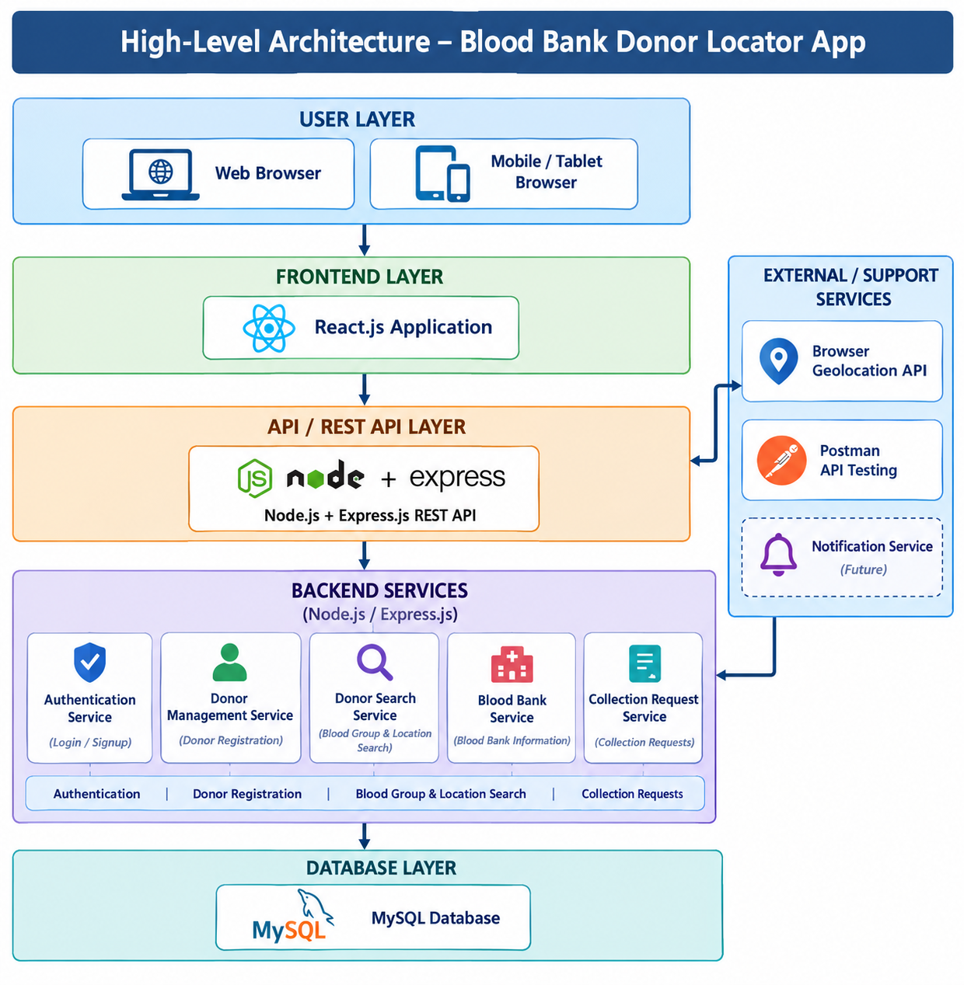

Description of Each Layer (Frontend, Backend, Database)

The architecture of the Blood Bank Donor Locator App follows a layered approach that separates the user interface, application logic, and data management components. This structure improves modularity, maintainability, scalability, and communication between different parts of the system. The three main layers are the Frontend Layer, Backend Layer, and Database Layer. The application also uses REST APIs and location services to support communication and location-based donor searching.

1. Frontend Layer

The Frontend Layer is the user interface of the Blood Bank Donor Locator App and is developed using React.js, HTML5, CSS3, and JavaScript. It allows users to interact with the application through a simple and responsive web interface. The frontend provides different pages and components such as Home, Find Donor, Donor Registration, Blood Bank, Collection Request, Login, Signup, and Collector.

The Find Donor interface allows users to search for potential donors using details such as blood group, name, and location. Location-based functionality can use the browser's Geolocation API to obtain the user's current coordinates. The Donor Registration interface collects donor information such as name, blood group, contact details, location, and basic health eligibility information. The Collection Request interface allows a request to be submitted using the donor ID and relevant location details.

React.js uses reusable components and state management to provide dynamic interaction between different pages. Form validation is performed before information is submitted to the backend. The frontend communicates with the backend through REST APIs and exchanges data mainly in JSON format. Responsive design allows the application to be accessed through desktops, laptops, tablets, and mobile browsers.

2. Backend Layer

The Backend Layer is responsible for the main processing and business logic of the application. It is developed using Node.js and Express.js and acts as an intermediate layer between the React.js frontend and the MySQL database. The backend receives requests from the frontend, processes the required operations, communicates with the database, and sends appropriate responses back to the user interface.

The backend provides REST API services for important application modules such as authentication, donor management, donor searching, blood bank information, and collection requests. It handles operations such as registering donors, retrieving donor records, searching donors by blood group and location, managing blood bank information, and processing collection requests.

The backend also performs input validation, error handling, authentication, authorization, and CORS configuration. Location information such as latitude and longitude can be received through API requests and stored for location-based operations. The modular structure of Node.js and Express.js makes it easier to maintain individual services and add new functionality in the future.

3. Database Layer

The Database Layer provides permanent storage for the information required by the Blood Bank Donor Locator App. The application uses MySQL as its relational database. It stores and manages important information such as donor details, blood groups, collector accounts, blood bank information, authentication data, and collection requests.

The donor records contain information such as donor ID, name, blood group, contact details, location, latitude, longitude, and eligibility status. Collection request records can contain the request ID, donor ID, collector ID, request status, address, location coordinates, and request date. Blood bank records store information such as blood bank name, location, address, and contact details.

The backend communicates with MySQL to perform CRUD operations such as creating, retrieving, updating, and deleting records. Primary keys and foreign keys are used to maintain relationships between related tables. Appropriate indexing can improve the performance of searches, especially when searching donors by blood group or location. Sensitive information such as passwords is handled securely using appropriate authentication and password-hashing mechanisms.

4. Interaction Between the Layers

The interaction between the three layers follows a systematic data flow. When a user performs an operation through the React.js frontend, the request is sent to the Node.js and Express.js REST API. The backend processes the request and communicates with the MySQL database when information needs to be stored or retrieved. The backend then sends the result to the frontend in JSON format, and React.js updates the user interface accordingly.

This layered architecture provides separation of concerns, meaning that changes to one layer can be made with minimal impact on the other layers. For example, the frontend design can be modified without changing the database structure, while database improvements can be implemented without significantly changing the user interface. This makes the application easier to develop, test, maintain, and extend.

Deployment Architecture (Cloud, Local, CI/CD Pipelines)

The deployment architecture of the Blood Bank Donor Locator App is designed to support reliable development, testing, and deployment of the web application. The system follows a simple deployment structure consisting of the local development environment, backend server, MySQL database, and production deployment environment. During development, the frontend and backend can be executed locally, allowing developers to test application functionality before deployment. The project uses Git and GitHub for version control and maintaining different versions of the source code.

The frontend deployment consists of the React.js application containing pages such as Home, Find Donor, Donor Registration, Blood Bank, Collection Request, Login, Signup, and Collector. After development and testing, the React application can be built into optimized production files and deployed to a suitable web hosting service. The frontend communicates with the deployed Node.js and Express.js backend through REST APIs.

The backend deployment hosts the Node.js and Express.js application that handles API requests and application logic. The backend provides services for donor management, donor search, authentication, blood bank information, and collection requests. The backend communicates with the MySQL database for storing and retrieving application data. Environment variables are used to store configuration information such as the server port, database connection details, and other sensitive settings instead of directly placing them in the source code.

The MySQL database stores important application information including donor details, blood groups, user accounts, blood bank information, and collection requests. During development, MySQL can be hosted locally using MySQL Server and managed through MySQL Workbench. For production deployment, the database can be hosted on a reliable cloud database service or a remote MySQL server. Regular database backups should be maintained to protect important records from accidental data loss.

Security is considered throughout the deployment process. Communication between the frontend, backend, and users should use HTTPS in the production environment. Database credentials and other sensitive configuration values should be stored as environment variables or secure deployment secrets. Authentication and authorization are implemented for protected application functions, while input validation and proper error handling help prevent invalid requests and common security problems.

The deployment architecture can be extended in the future to support cloud hosting, automated database backups, monitoring, notification services, and scalable server infrastructure. The application can also be configured so that the frontend and backend are deployed separately while continuing to communicate through REST APIs. This provides flexibility as the number of users and blood donation requests increases.

In conclusion, the deployment architecture provides a clear path from local development to production deployment. React.js manages the frontend, Node.js and Express.js provide the backend REST APIs, and MySQL manages persistent application data. Git and GitHub provide version control, while CI/CD using GitHub Actions can automate testing and deployment. This structure makes the Blood Bank Donor Locator App easier to develop, test, maintain, and deploy while providing a foundation for future expansion.

CHAPTER -5 DESIGN

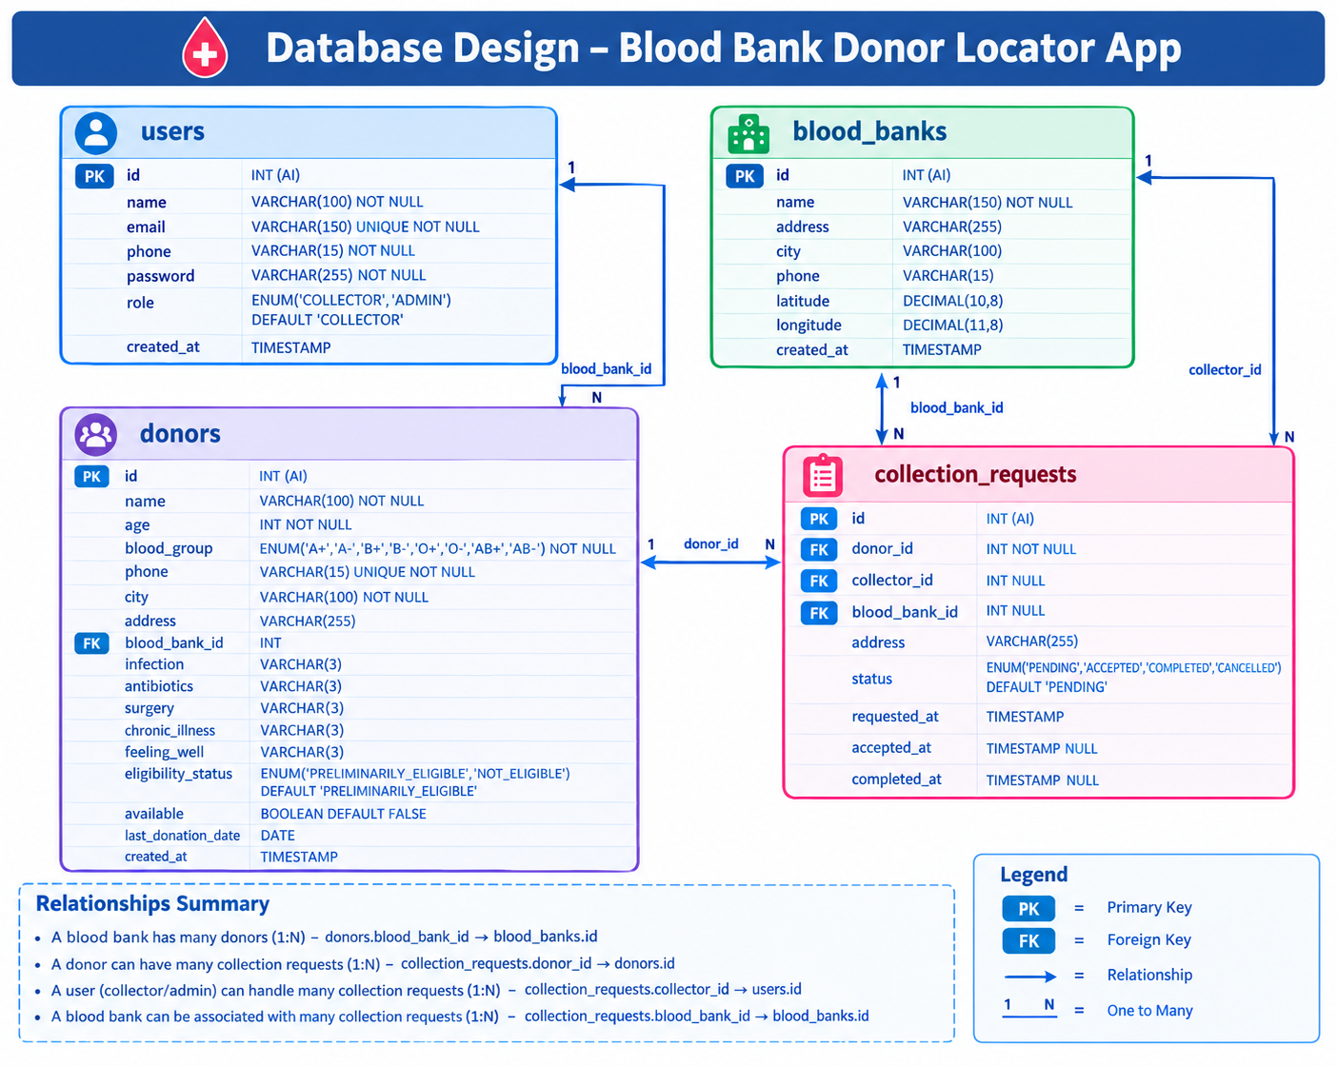

CHAPTER -6 IMPLEMENTATION

Section 6.1 – Module-Wise Implementation

The implementation of the Blood Bank Donor Locator App is organized into interconnected modules, with each module performing a specific function while communicating with the other modules through REST APIs. This modular structure improves maintainability, scalability, and usability of the application. The major modules include Home, Donor Registration, Donor Search, Blood Bank Management, Collection Request, Authentication, and Collector Management. Together, these modules provide a complete platform for registering donors, locating suitable donors, managing blood bank information, and coordinating blood collection requests.

1. Home Module

The Home Module provides the main entry point to the application. It introduces the purpose of the Blood Bank Donor Locator App and provides navigation to important features such as finding donors, donor registration, blood banks, login, and signup. The home page is designed with a simple and user-friendly interface so that users can quickly access the required functionality. Application statistics and important information can be retrieved from the backend rather than being maintained as static values.

2. Donor Registration Module

The Donor Registration Module allows individuals to register as blood donors without requiring a separate donor login account. The module collects important information such as name, age, blood group, phone number, city, location coordinates, and basic health-related eligibility information.

Before completing registration, the donor provides answers to pre-screening questions related to conditions such as infection, antibiotics, recent surgery, chronic illness, and current health condition. Based on these responses, the system determines a preliminary eligibility status. Donors who do not satisfy the basic conditions are informed that they cannot proceed, while preliminarily eligible donors can continue with the donation process.

The donor information is submitted through the REST API and stored in the MySQL donors table. The donor's phone number is maintained as unique to reduce duplicate donor records. The module also supports storing the donor's selected blood bank and geographical coordinates.

3. Find Donor Module

The Find Donor Module is one of the main functionalities of the application. It allows users to search for potential donors based on blood group, name, and location. The search functionality communicates with the backend through REST APIs and retrieves matching donor information from the MySQL database.

Location-based searching is supported using geographical information such as latitude and longitude. The browser Geolocation API can obtain the user's current location after permission is granted. This information can be used to identify donors based on their location and support proximity-based donor searching. Partial location or city-based searches can also be used to make donor identification easier.

4. Blood Bank Module

The Blood Bank Module provides information about available blood bank facilities. It stores details such as blood bank name, address, city, phone number, latitude, and longitude. Users can view blood bank information through the frontend, while the backend retrieves the required records from the MySQL database.

The module is also connected with donor registration and collection requests. A donor can select a blood bank where they intend to donate, and the selected blood bank can be associated with the donor record. This provides better coordination between donors and blood bank facilities.

5. Collection Request Module

The Collection Request Module is responsible for coordinating blood collection between donors and collectors. After a donor is eligible and chooses the collection option, a collection request can be created using the donor ID. The request may contain the donor's location, address, latitude, longitude, selected blood bank, and request time.

The request initially receives a PENDING status. A collector can view available requests and accept a suitable request. The status can then be changed to ACCEPTED, and after successful collection it can be marked as COMPLETED. A request can also be marked as CANCELLED when required. The collection_requests table maintains these details and establishes relationships with the donor, collector, and blood bank records.

6. Authentication Module

The Authentication Module provides secure login and registration functionality for authorized application users. In the current system, authentication is mainly provided for collectors and administrators, while donors can register directly without creating a login account.

The module manages user information such as name, email, phone number, password, and role. The role field distinguishes between COLLECTOR and ADMIN. Authentication APIs validate user credentials before providing access to protected application functions. Passwords are stored using secure password-handling practices rather than storing plain-text passwords.

7. Collector Management Module

The Collector Management Module provides collectors with an interface to manage blood collection requests. After authentication, collectors can view pending requests and access relevant donor and location information required for collection coordination.

Collectors can accept requests and update their status as the collection process progresses. The collector ID is stored in the collection request record, allowing the system to maintain information about which collector is handling a particular request. This module reduces manual coordination and provides an organized way to manage blood collection activities.

8. Database Management Module

The Database Management Module provides centralized storage for the application. MySQL is used to maintain structured information through tables such as users, blood_banks, donors, and collection_requests.

Relationships between tables are maintained using primary keys and foreign keys. For example, a donor can be associated with a blood bank, while a collection request is connected to a donor, collector, and blood bank. Constraints such as unique phone numbers, valid blood groups, and defined request statuses help maintain data consistency.

9. API and Integration Module

The API and Integration Module connects the React.js frontend with the Node.js and Express.js backend. REST APIs are used to perform operations such as donor registration, donor searching, authentication, blood bank retrieval, and collection request management.

The application also uses the Browser Geolocation API for obtaining location information when required. Data is exchanged between the frontend and backend using JSON. API testing can be performed using Postman to verify requests, responses, validation, and error handling.

10. Overall Module Integration

All modules work together as a unified system. A donor can register through the Donor Registration Module, complete preliminary eligibility screening, select a blood bank or collection option, and provide location information. Users can then search for suitable donors through the Find Donor Module, while collectors can manage collection requests through the Collector Management Module. The Blood Bank Module provides relevant facility information throughout this process.

The modular implementation ensures that each component has a clearly defined responsibility while maintaining communication through the backend REST APIs. This makes the application easier to test, maintain, and extend. Future improvements can include automated notifications, appointment scheduling, real-time donor availability, SMS or email services, and integration with authorized blood bank systems.

Section 6.2 – Front-End Logic (UI Rendering and State Management)

The front-end of the Blood Bank Donor Locator App is responsible for providing users with a simple, responsive, and interactive interface for accessing blood donation services. It is developed using React.js, HTML5, CSS3, and JavaScript. The main purpose of the front-end logic is to convert backend operations such as donor registration, donor searching, blood bank information retrieval, authentication, and collection request management into an easy-to-use interface.

The application follows a component-based architecture in React.js. Different pages and components are developed for specific functions, including Home, Find Donor, Donor Registration, Blood Bank, Collection Request, Login, Signup, and Collector. Reusable components and common navigation elements help maintain consistency across the application. React's component-based structure also allows individual sections to be modified without affecting the complete application.

UI Rendering
React.js manages the rendering of the application based on the current application state. When a user navigates between pages or performs an operation, only the required components are updated instead of reloading the complete webpage. This provides a smooth user experience.

The Home page provides navigation to the main features of the application. The Find Donor page displays search fields for blood group and location and presents matching donor information returned from the backend. The Donor Registration page provides forms for entering donor details and preliminary health screening information. The Blood Bank page displays available blood bank information, while the Collection Request page allows eligible donors to submit collection requests.

The Login and Signup pages provide authentication-related interfaces for collectors and administrators. After successful login, the Collector interface displays collection requests and relevant donor information. Conditional rendering is used to display different content depending on the user's login status and application state.

State Management

State management is an important part of the React.js frontend. The application maintains values such as blood group, location, donor information, loading status, search results, authentication information, and collection request details using React state mechanisms.

Form Handling and Validation

Forms are an important part of the application's front-end logic. The Donor Registration form collects information such as name, age, blood group, phone number, city, and health-related screening responses. Before sending the information to the backend, the frontend performs basic validation to ensure that required fields are completed correctly.

The application also provides validation for login, signup, donor search, and collection request forms. Meaningful error messages are displayed when required information is missing or an operation cannot be completed. This helps users correct mistakes before submitting data to the backend.

API Communication

The React.js frontend communicates with the Node.js and Express.js backend through REST APIs. When a user performs an operation such as registering a donor or searching for a donor, the frontend sends an asynchronous HTTP request to the appropriate API endpoint.

The response from the backend is received in JSON format and stored in the appropriate React state. The interface is then automatically re-rendered to display the latest information. Loading indicators and error messages are used while API operations are being processed.
Location-Based Front-End Logic

Location functionality is an important feature of the application. The frontend can use the Browser Geolocation API to request the user's current latitude and longitude after obtaining permission. The captured coordinates can be used for location-based donor searches and collection requests.

The location information is maintained in the frontend state and can be sent to the backend through REST API requests. This supports the application's objective of helping users identify donors or collection-related services based on geographical location.

Conditional Rendering and User Feedback

Conditional rendering is used throughout the application to provide appropriate content according to the current state. For example, a loading message can be displayed while donor information is being retrieved, search results can be displayed after a successful request, and an appropriate message can be shown when no matching donors are found.

The donor registration flow also uses conditional logic based on preliminary eligibility responses. If a donor does not satisfy the defined pre-screening conditions, the application displays a notification indicating that the donor cannot proceed. If the donor passes the preliminary screening, the application provides the next available donation options.

Responsive and User-Friendly Design

The frontend is designed to work across different screen sizes, including desktops, laptops, tablets, and mobile browsers. CSS techniques such as responsive layouts, flexible components, and appropriate spacing are used to provide a consistent interface.

The application focuses on simple navigation and clear presentation of important information. Blood groups, donor details, blood bank information, request status, and action buttons are presented in an organized manner so users can understand the available options easily.

Error Handling and Performance

Error handling is incorporated into the frontend to manage situations such as unsuccessful API requests, invalid input, unavailable donor records, or denied location permissions. Instead of leaving the interface in an uncertain state, the application displays meaningful feedback to the user.

Asynchronous API calls prevent the user interface from becoming unresponsive while information is being retrieved from the backend. Loading states are maintained during important operations, and unnecessary API requests can be avoided through appropriate state handling.

Front-End and Backend Integration

The front-end logic acts as the communication layer between the user and the backend services. User actions such as donor registration, searching, login, blood bank selection, and collection request submission generate API requests. The backend processes these requests and communicates with the MySQL database before returning the required response.

This separation between frontend presentation and backend processing allows the user interface to be modified without changing the core database logic. It also makes the application easier to test, maintain, and extend.

6.3 API Integration

The API Integration stage forms the communication backbone of the Blood Bank Donor Locator App, connecting the React.js frontend with the Node.js and Express.js backend. Through Application Programming Interfaces (APIs), the frontend can send requests to the server and receive information without directly accessing the database. This allows operations such as donor registration, donor searching, authentication, blood bank information retrieval, and collection request management to be performed in an organized manner.

The application follows a RESTful API architecture. The backend is developed using Node.js and Express.js, and different routes are created for specific application modules. The API layer acts as an intermediate component between the frontend and MySQL database. When a user performs an operation, the React.js frontend sends an HTTP request to the appropriate backend endpoint. The backend processes the request, communicates with MySQL when required, and returns the result to the frontend in JSON format.

The Donor API manages donor registration and donor information. When a donor submits the registration form, the frontend sends the donor details to the backend using a POST request. The backend validates the information and stores it in the donors table. Donor information can subsequently be retrieved through GET requests for searching and displaying donor records.

The Donor Search API is responsible for finding potential donors according to selected search criteria. Users can search using information such as blood group, name, and city or location. The frontend sends these parameters to the backend, which processes the search conditions and retrieves matching records from MySQL. The returned JSON data is then displayed dynamically in the Find Donor interface.

The Authentication API handles login and registration for authorized users such as collectors and administrators. Login information is submitted from the React frontend to the backend, where the credentials are validated against the users table. The user's role, such as COLLECTOR or ADMIN, can be used to control access to protected application functions.

The Blood Bank API manages information about blood bank facilities. It allows the frontend to retrieve details such as blood bank name, address, city, phone number, latitude, and longitude. These records are stored in the blood_banks table. The API allows blood bank information to be displayed on the application and associated with donor registration or collection requests.

The Collection Request API manages requests created for blood collection. A request can contain the donor ID, collector ID, blood bank ID, donor location, address, and request status. When a donor submits a collection request, the frontend sends the information to the backend through a POST request. The backend stores the request in the collection_requests table. Collectors can then retrieve pending requests and update their status to ACCEPTED, COMPLETED, or CANCELLED.

Location-based functionality is supported using the Browser Geolocation API. With the user's permission, the browser can provide latitude and longitude coordinates. These coordinates can be sent to the backend through API requests and stored with donor or collection request information. This supports location-based donor searching and helps collectors identify the location associated with a collection request.

The API layer also includes input validation and error handling. Required fields are checked before information is stored in the database, and appropriate responses are returned when invalid data, missing records, authentication failures, or server errors occur. HTTP status codes such as 200 (OK), 201 (Created), 400 (Bad Request), 401 (Unauthorized), 404 (Not Found), and 500 (Internal Server Error) can be used to communicate the result of API operations.

Security is considered during API communication. CORS is configured to control communication between the frontend and backend when they operate on different origins. Authentication is applied to protected operations, while passwords are handled using secure password-hashing techniques. Database credentials and other sensitive configuration information are maintained through environment variables rather than being directly exposed in the source code.

API testing is performed using Postman. Different API endpoints can be tested by sending GET, POST, PUT, and DELETE requests and checking the returned responses. Testing includes valid requests, invalid input, missing fields, authentication failures, and database-related errors. This helps verify that each backend module communicates correctly with the frontend and database.

The complete API communication follows a clear sequence: the user interacts with the React.js frontend → frontend sends a REST API request → Node.js/Express.js processes the request → MySQL stores or retrieves data → backend returns a JSON response → React.js updates the user interface. This process allows the application to provide dynamic information without requiring complete webpage reloads.

6.4 Authentication and Authorisation

The Authentication and Authorisation Module is an important security component of the Blood Bank Donor Locator App. It protects user accounts and controls access to functions based on the user's role. Authentication verifies the identity of a registered user, while authorization determines which operations the user is allowed to perform. In the current system, authentication is mainly provided for collectors and administrators, while donors can register directly without creating a login account.

The application maintains authenticated user information in the users table of the MySQL database. Each user record contains information such as user ID, name, email, phone number, password, role, and account creation time. The role is defined as either COLLECTOR or ADMIN, allowing the system to distinguish between different types of authorized users.

During registration, the user provides required information such as name, email, phone number, and password. The backend validates the submitted information and checks whether the email already exists in the database. Passwords are not stored as plain text; secure password-hashing techniques are used before storing them in the database. This helps protect user credentials even if database records are exposed.

During login, the user enters their registered email and password through the React.js login interface. The credentials are sent to the Node.js and Express.js backend through an authentication API. The backend retrieves the corresponding user record from MySQL and verifies the submitted password against the stored hashed password. If the credentials are valid, the user is authenticated and can access the functions permitted for their role.

Authorization is applied on the backend to protect important API endpoints. Before processing a protected operation, the backend checks whether the request belongs to an authenticated user and whether that user's role has the required permission. This prevents unauthorized users from directly accessing protected API operations even if they attempt to call the endpoint manually.

The frontend also uses conditional rendering to provide an appropriate interface based on authentication and role information. For example, collector-related options are displayed to authenticated collectors, while administrative functions can be restricted to administrators. This improves usability by showing users only the operations relevant to their role. However, frontend restrictions are treated as a usability feature, while the backend remains responsible for enforcing actual authorization.

Error handling is included in the authentication process. Incorrect login credentials result in an appropriate error message rather than granting access. Requests made without valid authentication can return an HTTP 401 (Unauthorized) response, while authenticated users attempting to access operations outside their permitted role can receive an HTTP 403 (Forbidden) response. This provides clear communication between the backend and frontend.

The authorization structure also supports future expansion. Additional roles or permissions can be introduced if the application is extended to include hospital staff, blood bank administrators, or other authorized users. Similarly, more detailed permissions can be added to control access to specific donor, blood bank, or collection management operations.

In conclusion, the Authentication and Authorisation Module provides a security layer for the Blood Bank Donor Locator App. Authentication verifies collectors and administrators, while role-based authorization controls their access to protected functions. Secure password handling, API-level authorization, validation, CORS configuration, and proper error handling help protect application data and maintain controlled access. This approach provides a secure foundation for managing donors, blood banks, and blood collection activities.

CHAPTER 7- FEATURES

List of Main Features

The Blood Bank Donor Locator App is designed as a centralized web-based platform that simplifies the process of finding potential blood donors and coordinating blood collection. The application brings together donor registration, donor searching, blood bank information, authentication, and collection request management within a single system. Each feature performs a specific function while communicating with the other modules through REST APIs and a centralized MySQL database.

The Donor Registration Feature allows individuals to register as potential blood donors without creating a separate login account. The registration process collects important information such as name, age, blood group, phone number, city, geographical location, and basic health-related screening responses. The system performs preliminary eligibility checking based on the provided responses. If the donor does not satisfy the defined conditions, the system displays an appropriate notification. If the donor passes the preliminary screening, the registration can proceed.

The Donor Search Feature is one of the main components of the application. It allows users to search for potential donors based on their blood group, name, and location. The backend retrieves matching donor records from the MySQL database and sends them to the frontend through REST APIs. Partial city or location searches can also be supported, making it easier to identify suitable donors when the exact location name is not known.

The Location-Based Donor Feature improves the donor search process by using geographical information. The application can obtain the user's current latitude and longitude through the Browser Geolocation API, with the user's permission. Donor location information can also be stored as latitude and longitude. This provides a foundation for identifying donors based on geographical proximity and helps users and collectors locate relevant donation resources.

The Collection Request Feature provides a mechanism for coordinating blood collection between donors and collectors. A donor can submit a collection request using the donor ID and provide relevant location and address information. The request is stored in the database with a status such as PENDING, ACCEPTED, COMPLETED, or CANCELLED. Collectors can view pending requests, accept suitable requests, and update their status after the collection process.

The Authentication Feature provides secure access for authorized application users. In the current system, collectors and administrators use the login functionality, while donors can register directly without a login account. User information is maintained in the users table, which contains the user's name, email, phone number, password, and role. Role-based access allows the application to distinguish between collector and administrator functions.

The Database Management Feature provides centralized storage for all important application information. The system uses MySQL with tables such as users, blood_banks, donors, and collection_requests. Primary keys and foreign keys establish relationships between these tables. For example, collection requests are associated with donors, collectors, and blood banks, allowing information to be retrieved in an organized manner.

The REST API Integration Feature connects the React.js frontend with the Node.js and Express.js backend. APIs are provided for authentication, donor management, donor searching, blood banks, collectors, and collection requests. HTTP methods such as GET and POST are used for retrieving and submitting information, while JSON is used for communication between the frontend and backend. This separation makes the system easier to maintain and extend.

The Validation and Error Handling Feature ensures that incorrect or incomplete information is handled appropriately. Required fields are validated during registration, login, donor searching, and collection request submission. If an API request fails or a matching donor is not found, the application provides suitable feedback to the user. This improves reliability and prevents invalid information from being unnecessarily stored in the database.

The Responsive User Interface Feature allows the application to be accessed through different devices such as desktops, laptops, tablets, and mobile browsers. React.js components provide dynamic rendering, while HTML5 and CSS3 are used to create the visual structure and responsive layouts. The interface focuses on simple navigation so that users can quickly access donor searching, registration, blood bank information, and collection services.

The API Testing and Development Feature supports reliable application development through tools such as Postman, Visual Studio Code, npm, MySQL Workbench, and Git/GitHub. Postman is used to test backend API endpoints, MySQL Workbench is used to manage the database, and Git/GitHub is used to maintain source-code versions. These tools support development, debugging, testing, and maintenance of the application.

How Each Feature Works

The operation of the Blood Bank Donor Locator App is based on the coordinated interaction between the user interface, application logic, REST APIs, and MySQL database. Each feature is designed to provide a simple and organized way to register donors, search for suitable donors, access blood bank information, and manage blood collection requests. The following sections describe how each feature works from both the user's perspective and the technical perspective.

1. Donor Registration Feature
User-Perspective:
The donor registration section allows a person to register as a potential blood donor without creating a separate login account. The user enters details such as name, age, blood group, phone number, city, and location. The form also contains basic health-screening questions related to infection, antibiotic usage, recent surgery, chronic illness, and current health condition.
After submitting the form, the system checks the entered information against the predefined preliminary eligibility conditions. If the donor does not satisfy the conditions, the application displays a notification indicating that the person cannot proceed with donation registration. If the conditions are satisfied, the donor can continue by selecting a blood bank or collection option.

Technical-Description:
The React.js frontend collects and validates the donor information and sends it to the Node.js and Express.js backend through a REST API. The backend processes the health-screening information and determines the preliminary eligibility status. Valid donor information is stored in the donors table in MySQL. The table maintains details such as blood group, contact information, city, latitude, longitude, eligibility status, availability, and last donation date. The donor does not require an entry in the authentication system.

2. Donor Search Feature
User-Perspective:
The Find Donor section allows users to search for potential donors based on their required blood group and location. Users can select a blood group and enter a city, area, or name. The application displays matching donor records in an organized format.
The search also supports partial location matching, making it easier to find donors when only part of a city or area name is known. The results provide relevant donor information required for further coordination.

Technical-Description:
The React frontend sends the selected search parameters to the donor search API. The Node.js and Express.js backend processes the request and executes a suitable query against the MySQL donors table. Search conditions can include blood group, name, and city. The matching records are returned as JSON data and dynamically rendered by React. Input validation and error handling are applied to prevent invalid search requests.

3. Location-Based Donor Feature
User-Perspective:
The application can use the user's current location to support location-based donor searching. When the user grants permission, the browser obtains the current geographical position. The interface displays the captured location and can use it as part of the donor search or collection process.
This feature helps users identify donors according to geographical proximity rather than depending only on manually entered city information.

Technical-Description:
The system uses the Browser Geolocation API to obtain the user's latitude and longitude. These coordinates are transferred to the backend when required and can be stored with donor or collection request information. Donor coordinates are maintained in the MySQL database. The stored coordinates provide the foundation for proximity-based searching and future distance calculations.

4. Blood Bank Information Feature
User-Perspective:
The Blood Bank section allows users to view information about available blood banks. Each blood bank entry provides details such as name, address, city, contact number, and location. During donor registration, the user can select a suitable blood bank for donation.
This provides donors with a clear connection between their registration information and the facility where donation may take place.

Technical-Description:
Blood bank information is stored in the blood_banks table in MySQL. The React frontend requests the information through the Blood Bank REST API. The backend retrieves the corresponding records and returns them in JSON format. The blood_bank_id field in the donor table establishes a relationship between a donor and the selected blood bank.

5. Collection Request Feature
User-Perspective:
The Collection Request feature allows a registered donor to request blood collection assistance. The donor information is identified using the donor ID, and the request can include the donor's location and address.
After submission, the request initially appears as Pending. A collector can review the request and accept it. After the collection process is completed, the request status can be updated accordingly. If the request is no longer required, it can also be cancelled.

Technical-Description:
The React frontend collects the donor ID and relevant location information and sends it to the Collection Request API. The Express.js backend validates the request and stores it in the collection_requests table. The table maintains donor ID, collector ID, blood bank ID, latitude, longitude, address, timestamps, and request status.
The request status follows the defined workflow:
PENDING → ACCEPTED → COMPLETED
A request can also be marked as CANCELLED when necessary. Foreign-key relationships connect the request with the corresponding donor, collector, and blood bank.

6. Authentication Feature
User-Perspective:
The Login and Signup pages provide account access for authorized application users such as collectors and administrators. Donors do not require an account to register as donors. During login, the user enters their registered email and password.
After successful authentication, the user is provided access to the functions associated with their role. This prevents unauthorized users from accessing collector or administrative functions.

Technical-Description:
User account information is maintained in the users table. The table contains the user's name, email, phone number, password, and role. The available roles are COLLECTOR and ADMIN.
The React frontend sends login information to the authentication API. The Node.js and Express.js backend validates the credentials against the database and applies role-based access control. Passwords are handled using secure password-hashing techniques. Unauthorized requests are rejected by the backend.

7. Collector Management Feature
User-Perspective:
The Collector section provides an interface through which authenticated collectors can view and manage collection requests. A collector can review pending requests, view relevant donor and location information, and accept requests that need to be handled.

Technical-Description:
Collector information is maintained in the users table with the COLLECTOR role. Collection requests contain a collector_id field that associates a particular request with the collector handling it. The React frontend communicates with collector and request APIs to retrieve and update request information. Backend authorization ensures that protected collector operations are available only to authenticated users with the required role.

8. Database Management Feature
User-Perspective:
The database functionality operates in the background and does not require direct interaction from normal users. It ensures that donor, blood bank, user, and collection request information remains available when users return to the application.

Technical-Description:
MySQL is used as the central relational database. The major tables are users, blood_banks, donors, and collection_requests. Primary keys uniquely identify records, while foreign keys establish relationships between related tables.

9. REST API Integration Feature
User-Perspective:
Users interact with the application through the React interface without directly communicating with the database. When a user registers, searches for a donor, views a blood bank, logs in, or submits a collection request, the application communicates with the backend automatically.

Technical-Description:
The system follows a REST-based architecture in which React communicates with the Node.js and Express.js backend using HTTP requests. APIs are provided for authentication, donors, collectors, collection requests, blood banks, and administrative operations.

10. Validation and Error Handling Feature
User-Perspective:
The application provides messages when required information is missing, incorrect, or when an operation cannot be completed. For example, duplicate phone numbers, invalid login credentials, unsuccessful searches, or incomplete collection requests are handled with appropriate feedback.

Technical-Description:
Validation is performed at the frontend and backend levels. React validates form inputs before submitting requests, while the Express.js backend performs server-side validation before modifying database records. Error-handling mechanisms return suitable HTTP responses for invalid requests, unauthorized access, missing records, and server errors.

11. Overall Feature Integration
User-Perspective:
All major features work together to provide a complete blood donation support process. A donor can register and complete preliminary screening, select a blood bank or collection option, and provide location information. Users can search for potential donors using blood group and location. Collectors can then manage collection requests through their authenticated interface.

Technical-Description:
The complete system follows the flow:
React Frontend → REST API → Node.js/Express Backend → MySQL Database → JSON Response → React Frontend

The frontend handles user interaction and presentation, the backend manages application logic and API processing, and MySQL provides persistent data storage. The separation of these layers makes the system easier to maintain, test, and extend.

CHAPTER -8 TESTING

Postman Testing (Frontend/Backend)

The reliability and functional accuracy of the Blood Bank Donor Locator App APIs were tested using Postman, an API testing and development tool. The testing process ensured that the React.js frontend communicated correctly with the Node.js and Express.js backend and that the data stored in the MySQL database was properly processed. Different real-world scenarios were tested to verify both successful and unsuccessful API responses.

Postman was used to directly send HTTP requests to the backend endpoints without depending on the graphical user interface. This made it easier to test individual services and identify errors in backend logic. API requests were tested using methods such as GET, POST, PUT, and DELETE, depending on the operation being performed.

The testing covered the major modules of the application, including donor registration, donor search, authentication, blood bank information, collector management, and collection requests. For donor registration, POST requests were used to verify that valid donor details were correctly inserted into the database. Invalid or incomplete data was also tested to ensure that appropriate error messages were returned.

The Donor Search API was tested using different blood groups, names, and city or location values. The responses were checked to ensure that matching donor records were returned correctly. Blood bank APIs were tested to verify that blood bank names, addresses, contact numbers, and location information were retrieved successfully.

The Authentication APIs were tested with valid and invalid login credentials. Successful requests were checked for proper authentication, while incorrect credentials were expected to be rejected. Collector and administrator access was also tested to verify that protected operations were available only to authorized users.

Postman was also used to verify the JSON response structure returned by the backend. Response data was compared with the expected database records to confirm data consistency between the API and MySQL database. Response time and server errors were also observed during testing.

Security-related API behaviour was checked by sending unauthorized requests to protected endpoints and verifying that access was rejected. Input validation and CORS configuration were also tested to ensure that the backend handled requests safely.

The tested Postman APIs were used alongside frontend testing to confirm complete communication between the React frontend, Express.js backend, and MySQL database. Postman collections can also be maintained in Git/GitHub so that the API test cases can be reused during future development.

Integration Testing

Integration testing was performed to verify the correct interaction between the different modules of the Blood Bank Donor Locator App. While unit testing focuses on individual functions or components, integration testing ensures that the React.js frontend, Node.js and Express.js backend, REST APIs, and MySQL database communicate correctly as a complete system. The main objective was to verify that data passed between different modules without loss, duplication, or inconsistency.

The testing environment was configured using the application frontend, backend server, and MySQL database. Different test records were used for donors, users, blood banks, and collection requests. Both normal and invalid scenarios were tested to observe how the complete application responded to different inputs and conditions.

The first stage of integration testing focused on the frontend and backend communication. User actions performed through React components were checked to ensure that the correct API requests were generated and sent to the Express.js server. The returned JSON responses were then verified to ensure that the frontend displayed the correct information.

The Location-Based Feature was tested by integrating the Browser Geolocation API with the donor and collection request modules. Latitude and longitude values obtained from the browser were checked to ensure that they were transferred correctly to the backend and stored where required. This testing verified that location information could be used for donor searching and collection coordination.

The Blood Bank Module was integrated with donor registration and the MySQL database. When a donor selected a blood bank, the corresponding blood_bank_id was stored with the donor record. The integration test verified that the correct blood bank information was retrieved and displayed, including name, address, city, phone number, latitude, and longitude.

The Collection Request Module was tested together with the donor, collector, and blood bank modules. A collection request was created using a valid donor ID and relevant location information. The request was then checked to ensure that it was correctly stored in the collection_requests table. Different request states—PENDING, ACCEPTED, COMPLETED, and CANCELLED—were tested to verify that changes were correctly reflected in both the database and frontend.

The Authentication Module was integrated with the users database and protected application features. Valid collector and administrator credentials were tested to verify successful login, while incorrect credentials were tested to confirm rejection. Role-based access was also verified to ensure that users could access only the operations associated with their assigned role.

Integration testing also covered error handling and validation across modules. Invalid inputs, missing fields, duplicate donor records, incorrect login information, invalid IDs, and unavailable records were used as test cases. The system was checked to ensure that the backend returned appropriate responses and that the frontend displayed understandable error messages without causing the application to stop.

Database consistency was another important part of the integration process. API responses were compared with the corresponding MySQL records to verify that information was correctly inserted, retrieved, and updated. Relationships between the users, blood_banks, donors, and collection_requests tables were also verified through their primary-key and foreign-key connections.

The complete application flow was finally tested from the user's perspective. A donor could register, complete preliminary health screening, select a blood bank or collection option, and provide location information. The donor could then be identified through the search functionality, while an authenticated collector could view and manage the related collection request.

Tools Used for Testing

The testing of the Blood Bank Donor Locator App was carried out using different development and testing tools to verify the correctness of the frontend, backend APIs, database operations, and overall system integration. These tools helped the development team identify errors, validate data, and ensure that the application functions correctly under different conditions.

1. Postman

Postman was the main tool used for testing the REST APIs of the application. It was used to send GET, POST, PUT, and DELETE requests to the Node.js and Express.js backend and examine the returned JSON responses.
The major APIs tested included donor registration, donor search, authentication, blood bank information, collector operations, and collection requests. Both valid and invalid requests were tested to verify proper response codes, data validation, error handling, and API behaviour.

2. MySQL Workbench

MySQL Workbench was used to create, manage, and verify the application's database. After performing API operations, the corresponding records were checked directly in the database to confirm that the data was stored correctly.
The users, blood_banks, donors, and collection_requests tables were examined during testing. Primary-key and foreign-key relationships were also checked to ensure consistency between related records.

3. Visual Studio Code

Visual Studio Code was used for developing, debugging, and testing both the React.js frontend and Node.js/Express.js backend. The integrated terminal was used to start the frontend and backend servers and execute npm commands.
The editor's debugging and error messages helped identify issues related to JavaScript, React components, API communication, routing, and backend processing.

4. Browser Developer Tools

The browser's Developer Tools were used to examine frontend behaviour and API communication. The Console was used to identify JavaScript and React errors, while the Network tab was used to monitor API requests and responses.
This was useful for checking whether donor registration, donor searching, login, blood bank retrieval, and collection request operations were correctly communicating with the backend.

5. Git and GitHub

Git and GitHub were used for version control and maintaining the project source code. Changes made to frontend, backend, and configuration files were tracked using Git commits.
GitHub also provided a centralized repository for storing the project and maintaining previous versions. This helped the development team review changes and restore earlier versions when necessary.

6. Node.js and npm

Node.js and npm were used to run the backend application and manage its dependencies. npm was used to install and maintain the packages required by the project.
During testing, the Node.js terminal output was monitored to identify server errors, API failures, database connection problems, and other backend issues.

7. Web Browser Testing

The application was tested using modern web browsers to verify page navigation, form submission, validation messages, donor search results, authentication, and dynamic data display.
Different application workflows were manually executed to ensure that the frontend correctly responded to backend data and displayed appropriate success or error messages.

8. Manual Testing

Manual testing was performed for important user workflows such as donor registration, health-condition checking, donor searching, blood bank selection, login, and collection request submission. Both valid and invalid inputs were entered to verify the expected application behaviour.

Test Cases and Results

The testing phase of the Blood Bank Donor Locator App was carried out systematically to verify the correctness, reliability, and proper integration of its major modules. Donor registration was tested using valid and invalid details to ensure that required fields were validated and duplicate phone numbers were handled correctly. The health eligibility feature was tested with different health-condition responses to verify that eligible and non-eligible donors were identified appropriately. The Find Donor module was tested using blood group, name, city, and partial location searches to confirm that matching donor records were displayed correctly. The location feature was tested using the browser Geolocation API to verify that the user’s latitude and longitude were captured and that appropriate messages were displayed when location permission was denied.

The Blood Bank module was tested to ensure that blood bank names, addresses, cities, contact details, and location information were displayed correctly. Collection requests were tested by submitting valid donor details and checking whether requests were created with the correct status and information. Collector login was tested with both valid and invalid credentials, and collector functions such as viewing and managing collection requests were verified. REST APIs were tested using Postman with different GET, POST, PUT, and DELETE requests to check response data, validation, and error handling. MySQL Workbench was used to verify that donor, user, blood bank, and collection request records were correctly stored and related through primary and foreign keys.

Integration testing was also performed to verify the complete flow between the React frontend, Node.js and Express.js backend, REST APIs, and MySQL database. Invalid inputs, missing records, duplicate data, and unauthorized requests were tested to ensure that suitable error messages and responses were returned. The test results confirmed that the major functionalities of the Blood Bank Donor Locator App operated as expected and that the frontend, backend, APIs, and database communicated correctly. Overall, the testing demonstrated that the application provides a functional and reliable platform for donor registration, donor searching, blood bank information, authentication, and collection request management.
.

CHAPTER -9 DEPLOYMENT

Steps to Deploy

The deployment of the Blood Bank Donor Locator App involves preparing the frontend, backend, and database so that the application can be accessed and used reliably. The first step is to ensure that the complete project is working correctly in the development environment. The React frontend, Node.js and Express.js backend, and MySQL database are configured and tested locally using Visual Studio Code, npm, and MySQL Workbench. All required dependencies are installed using npm, and the database tables such as users, donors, blood_banks, and collection_requests are created and verified in MySQL. The backend environment variables, including the server port and database connection details, are configured before starting the application.

The next step is to prepare the frontend and backend for deployment. The React application is tested to ensure that pages such as Home, Find Donor, Donor Registration, Blood Bank, Login, Signup, and Collection Request communicate correctly with the backend APIs. The backend is started using Node.js and Express.js, and the REST API endpoints are verified using Postman. The frontend API URLs are configured to point to the deployed backend instead of the local development address. The React application can then be generated as a production build using the npm run build command. The backend is deployed on a server or hosting environment capable of running Node.js, while the MySQL database is hosted locally for development or on a suitable database server for production.

After deployment, the database connection and API communication are verified. The application is checked to ensure that donor registration correctly stores records in the MySQL database, donor searches return appropriate results, blood bank information is displayed, and collection requests are created and managed correctly. Authentication for collectors and administrators is also tested using valid and invalid credentials. Location-based functionality is verified through the browser Geolocation API, ensuring that latitude and longitude information can be captured when permission is provided. CORS and environment configuration are checked so that the React frontend can communicate securely with the Node.js backend.

Environment Configuration

The environment configuration of the Blood Bank Donor Locator App was established to provide a consistent and reliable setup for development, testing, and deployment. The application uses a three-layer architecture consisting of a React.js frontend, Node.js and Express.js backend, and MySQL database. Visual Studio Code was used as the main development environment, while MySQL Workbench was used for creating, managing, and verifying the database. A modern web browser such as Google Chrome was used to run and test the frontend application. Node.js and npm were installed to manage the application dependencies and execute the frontend and backend services.

The frontend environment was configured using React.js, JavaScript, HTML5, and CSS3. The required libraries and dependencies are maintained through the package.json file and installed using npm. The frontend contains modules such as Home, Find Donor, Donor Registration, Blood Bank, Collection Request, Login, Signup, and Collector. React state management is used to handle donor information, search values, loading states, authentication-related data, and collection requests. The frontend communicates with the backend through REST APIs and receives data in JSON format. API addresses are configured according to the environment so that the application can communicate with the appropriate backend server.

The backend environment was configured using Node.js and Express.js. Separate routes are used for authentication, donors, collectors, blood banks, and collection requests, making the backend modular and easier to maintain. Express middleware is used for JSON request processing, CORS configuration, and request handling. The backend connects to the MySQL database and performs operations such as inserting donor records, searching donors, retrieving blood bank information, managing collection requests, and handling user authentication. Environment configuration is used for important values such as the server port and database connection details, preventing sensitive information from being directly exposed in the application source code.

The application also uses the Browser Geolocation API to obtain the user's latitude and longitude when location permission is granted. This configuration supports location-based donor searching and allows location information to be included in collection requests. Postman is used to test the backend REST APIs independently of the frontend. Browser Developer Tools are used to inspect console errors, network requests, API responses, and frontend behaviour during testing. These tools help identify communication problems between the frontend and backend and assist in debugging the application.

Git and GitHub are used for version control and project management. The frontend and backend source code are maintained in the project repository, while unnecessary or sensitive files such as node_modules and environment configuration files can be excluded using .gitignore. The npm package configuration ensures that the required dependencies can be installed consistently when the project is moved to another development or deployment environment.

For deployment, the React application can be prepared using the npm run build command, which generates the production-ready frontend files. The Node.js and Express.js backend is configured to run on the required server port and must have access to the MySQL database. The frontend API configuration is updated to use the deployed backend address rather than a local development address. CORS settings are configured to permit communication between the deployed frontend and backend. In a production environment, HTTPS, secure environment variables, database backups, and restricted database access should also be maintained.

Hosting of Frontend and Backend

The hosting of the Blood Bank Donor Locator App represents an important stage in making the developed application accessible beyond the local development environment. The system follows a client-server architecture in which the React.js frontend provides the user interface, the Node.js and Express.js backend handles application logic and REST API requests, and the MySQL database stores and manages application data. During development, these components are executed separately on the local system, allowing the development team to test communication between the frontend, backend, and database before making the application accessible through a network or deployment environment.

Frontend Hosting: The frontend of the Blood Bank Donor Locator App is developed using React.js along with HTML5, CSS3, and JavaScript. It provides the main user interface through modules such as Home, Find Donor, Donor Registration, Blood Bank, Collection Request, Login, Signup, and Collector. During development, the React application is started using npm and accessed through the browser using its local development address. Before deployment, the application can be converted into an optimised production version using the npm run build command. This process generates the static files required to run the React application in a production hosting environment. The generated frontend files can be hosted on a suitable static web hosting service or web server, allowing users to access the application through a browser from different devices.

The frontend communicates with the backend through REST API requests. Therefore, the API base URL configured in the React application must point to the accessible backend server rather than the local development address. This configuration is important when the application is accessed from another computer or mobile device because localhost refers to the device on which the browser is running. The frontend configuration is therefore updated according to the deployed backend address. CORS configuration on the backend is also required to permit communication between the frontend and backend when they are hosted at different addresses or domains.

Backend Hosting: The backend of the application is developed using Node.js and Express.js. It provides the REST APIs required by the frontend for donor registration, donor searching, authentication, blood bank information, collector management, and collection request processing. The backend follows a modular structure with separate routes for major application functions. During development, the Express server runs on the configured port and receives requests from the React frontend. For deployment, the Node.js application can be hosted on a server or a hosting platform that supports Node.js applications.

The backend is responsible for processing incoming requests, validating data, communicating with the MySQL database, and returning appropriate JSON responses to the frontend. The server configuration includes values such as the application port and database connection information. These settings should be maintained through environment configuration rather than exposing sensitive information directly within the source code. The backend also uses CORS to control communication between the frontend and server. Proper error handling is implemented so that invalid requests, missing records, authentication failures, and database errors return suitable responses to the frontend.

Database Connectivity: The backend is connected to the MySQL blood_bank database, which stores the application's main information. The database contains tables such as users, donors, blood_banks, and collection_requests. When a donor registers, the backend receives the submitted information from the React frontend and stores the appropriate data in the donors table. Similarly, collection requests are stored in the collection_requests table and linked with the corresponding donor, collector, and blood bank through foreign-key relationships. The hosted backend must therefore have continuous and secure access to the configured MySQL database.

Network Configuration: Network configuration is an important part of hosting because the frontend and backend may operate on different addresses. During local testing, the frontend and backend can communicate through local network addresses, while deployment requires publicly accessible or appropriately networked addresses. The backend port must be available to receive API requests, and firewall or hosting settings should allow only the required network traffic. CORS must be configured according to the actual frontend address so that authorised frontend requests are accepted while unwanted origins can be restricted. When the application is deployed for public use, HTTPS should be enabled to protect communication between users and the application.

Location and API Services: The application uses the browser's Geolocation API for location-based functionality. When a user provides location permission, the browser obtains the current latitude and longitude, which can be used for donor search and collection request information. Since browser location services depend on user permission and browser support, the hosted application must be accessed through a secure environment when required by the browser's geolocation security restrictions. REST APIs connect the location-enabled frontend with the backend, allowing location information and other donor data to be processed and stored where required.

Security Configuration: Security is considered during the hosting of both frontend and backend components. Collector and administrator authentication is handled through the backend, while donors do not require a separate login account in the implemented workflow. Passwords should be stored securely using password hashing rather than plain-text storage. Database credentials and other sensitive configuration values should not be committed to GitHub or exposed in frontend code. Appropriate authentication and authorisation checks are applied to protected backend operations. HTTPS should be used in a production environment to protect credentials and other information transferred between the browser and server.

Post-Deployment Verification: After the frontend and backend are hosted, the complete application is tested again to ensure that all components communicate correctly. Donor registration is verified by submitting valid donor information and checking whether the record is correctly stored in MySQL. The Find Donor module is tested using blood group, name, and city or location searches. Blood bank details are checked to ensure that the correct information is retrieved from the database. Collector login and collection request operations are also tested to verify that authentication and request management work correctly after deployment.

Overall, the hosting architecture of the Blood Bank Donor Locator App separates the React frontend, Node.js and Express.js backend, and MySQL database while maintaining communication between them through REST APIs. This separation improves maintainability and allows each layer to be managed independently. Proper API configuration, database connectivity, CORS, authentication, location services, HTTPS, testing, and version control together provide a structured hosting environment. The resulting architecture allows the application to move from local development to a publicly accessible system capable of supporting donor registration, donor searching, blood bank information, authentication, and collection request management across different devices.

CHAPTER -10 CHALLENGES & LIMITATIONS

Issues Faced During Development

The development of the Blood Bank Donor Locator App involved several technical and practical challenges across the frontend, backend, database, API integration, location services, testing, and deployment stages. Since the application combines donor registration, health eligibility checking, location-based donor searching, blood bank information, authentication, and collection request management, maintaining proper communication between different modules required careful development and testing. The issues encountered during implementation helped the development team improve the reliability, usability, and integration of the overall system.

One of the major challenges was establishing reliable communication between the React.js frontend and the Node.js and Express.js backend. During development, API requests sometimes failed because of incorrect backend URLs, CORS configuration, server-port differences, or the backend server not running. This became particularly important when testing the application from another device, because the local localhost address could not be directly accessed from external devices. The issue required proper configuration of the frontend API URLs, backend CORS settings, and network access so that requests could successfully reach the Express.js server.

Another important challenge was implementing the donor registration and health eligibility process. The donor registration form contains several fields including name, age, blood group, phone number, city, location, and health-related questions. Proper validation was required to prevent incomplete or invalid information from being stored in the database. Duplicate phone numbers also had to be handled because the donor phone number is maintained as a unique field. The health-condition responses needed to be processed correctly so that donors who did not satisfy the preliminary eligibility conditions were identified as not eligible rather than being incorrectly registered as available donors.

The donor search functionality also required careful handling because users can search using different criteria such as blood group, name, city, and location. Partial city or location searches had to be supported instead of requiring an exact text match. In addition, donor location information had to be stored using latitude and longitude so that location-based searching could be supported. Designing the search queries and returning the correct donor records from MySQL required testing with different combinations of search inputs, including empty fields, unmatched locations, and multiple matching donors.

Location functionality presented another challenge during development. The application uses the browser Geolocation API to obtain the user's current latitude and longitude. Location access depends on browser permission, and the application must handle both successful and denied permission cases. During testing, differences between local addresses, network access, browser security restrictions, and location permissions affected the behaviour of the feature. Appropriate messages and error handling were therefore required when the browser could not provide the user's location.

The collection request module also introduced integration challenges because a request involves information from multiple parts of the system. A valid request must contain the appropriate donor information and may include collector, blood bank, latitude, longitude, and address information. The request status must also be maintained correctly through stages such as PENDING, ACCEPTED, COMPLETED, and CANCELLED. Testing was required to ensure that only valid donor information could be associated with a request and that status changes were reflected correctly in the database and frontend.

Authentication and role management presented additional challenges. The application provides login functionality for collectors and administrators, while donors do not require a separate login account. The system therefore had to distinguish between different user roles and provide appropriate access to protected operations. Invalid login credentials, missing users, and unauthorised operations had to be handled correctly. Passwords also needed to be protected through secure hashing rather than storing them as plain text. These requirements made backend validation and authorisation important parts of the implementation.

Frontend development also involved challenges related to state management and dynamic data. React components had to maintain values such as donor information, blood group selection, search location, loading states, API responses, login information, and collection request details. Incorrect state updates could result in old information being displayed or components not updating after an API response. Conditional rendering was therefore used to display loading indicators, validation messages, search results, eligibility notifications, and error messages according to the current application state.

Solutions Applied

The challenges encountered during the development of the Blood Bank Donor Locator App were addressed through systematic debugging, modular development, API testing, database verification, and repeated integration testing. Since the application consists of React.js, Node.js and Express.js, REST APIs, MySQL, authentication, and location-based functionality, solutions were applied at each layer of the system to ensure reliable communication and consistent data processing. The development process involved identifying the source of each issue, testing possible solutions, and verifying the corrected behaviour through the application, Postman, browser developer tools, and MySQL Workbench.

To resolve frontend and backend communication problems, the application was organised using a clear REST API structure. Separate Express.js routes were created for authentication, donors, collectors, blood banks, and collection requests. The React frontend communicates with these endpoints using HTTP requests and JSON data. API URLs were checked carefully to ensure that the frontend was sending requests to the correct backend address and port. CORS configuration was added to the Express server to allow the frontend to communicate with the backend. During testing, Postman was used to verify the APIs independently, which helped distinguish frontend problems from backend or database problems.

The donor registration and health eligibility issues were addressed by implementing validation at both the frontend and backend levels. The React registration form checks required fields before submitting information, while the Express backend performs additional validation before inserting records into MySQL. The donor phone number was configured as a unique field in the database to prevent duplicate donor registrations. Health-related questions were processed according to the application's eligibility conditions, allowing the system to assign the appropriate preliminary eligibility status. This approach reduced invalid records and ensured that incomplete or unsuitable information was not stored incorrectly.

To improve donor searching, the backend donor API was designed to accept different search parameters such as blood group, name, city, and location-related information. SQL queries were adjusted to support partial text matching so that users could search using part of a city or location name rather than requiring an exact match. Empty search parameters were also handled appropriately so that the API did not generate invalid queries. The returned donor records were converted into JSON responses and displayed dynamically in the React frontend. Different combinations of blood groups and locations were tested to verify that the search results matched the requested criteria.

The location-related challenges were addressed using the Browser Geolocation API. The frontend requests permission from the user and obtains latitude and longitude when access is granted. These coordinates can be used during donor searching and collection request submission. Separate handling was implemented for cases where the user denies permission, the browser cannot obtain a location, or location information is unavailable. Appropriate messages are displayed instead of allowing the application to fail silently. Location values are stored in the database using latitude and longitude fields, allowing the backend to retain the required geographical information.

Database consistency problems were addressed through a structured MySQL schema with primary keys, foreign keys, unique constraints, and appropriate data types. The users, donors, blood_banks, and collection_requests tables were designed according to the relationships between the different application modules. Foreign-key relationships ensure that collection requests refer to valid donors, collectors, and blood banks. Duplicate phone numbers are prevented through the unique constraint on the donor phone field. MySQL Workbench was used to inspect tables, execute queries, verify inserted records, and identify incorrect or duplicate data. This helped maintain consistency between the information displayed in the frontend and the information stored in the database.

The collection request integration problems were solved by linking requests to the appropriate donor and other related information through database IDs. When a collection request is submitted, the donor ID, location information, address, and selected blood bank information can be sent to the backend. The backend validates the request before storing it in the collection_requests table. Request status values such as PENDING, ACCEPTED, COMPLETED, and CANCELLED are used to represent the progress of a collection request. This structured status management allows collectors to identify and manage requests according to their current state.

Authentication and authorisation issues were addressed by separating donor functionality from collector and administrator access. Donors do not require a separate login account in the implemented registration workflow, whereas collectors and administrators use the authentication module. User roles are maintained in the users table using the COLLECTOR and ADMIN roles. Passwords are protected using password hashing, and backend checks are used to restrict protected operations. Invalid credentials are rejected and appropriate authentication errors are returned. This approach ensures that authentication is handled by the backend rather than relying only on frontend restrictions.

Frontend state and rendering issues were resolved by managing component state carefully using React. State variables are used for donor details, blood group, location, search results, loading indicators, authentication information, and collection request data. Conditional rendering is used to display loading messages, validation errors, eligibility notifications, donor results, and other dynamic information according to the current state. API responses are processed before updating the relevant state, reducing the possibility of displaying outdated information. Local storage is used where required for maintaining client-side session-related information between page changes.

API testing and debugging were improved by using Postman as an independent testing tool. Each important endpoint was tested with valid, invalid, incomplete, and duplicate data. Successful responses and error responses were checked to ensure that the API returned appropriate HTTP status codes and JSON data. Browser Developer Tools were used to inspect console errors and Network requests from the React application. When an API failed, the request URL, request body, response status, and backend output were examined to identify the source of the problem. This approach helped resolve issues more efficiently than testing only through the graphical interface.

Cross-device and deployment-related problems were addressed by separating the frontend URL from the backend API URL and configuring the application according to the network environment. During local development, localhost or local network addresses were used, while cross-device testing required the backend to be reachable from the device accessing the frontend. CORS and host configuration were adjusted where required. When temporary tunnelling was used for testing, the changing tunnel URL had to be reflected in the frontend API configuration. These steps helped identify the difference between a locally working application and an application that must communicate across different devices.

Current Limitations or Known Bugs

Despite the successful implementation and testing of the Blood Bank Donor Locator App, certain limitations remain due to the current project scope, development environment, and dependency on browser and network services. The application provides the major functionalities required for donor registration, health eligibility checking, donor searching, blood bank information, authentication, and collection request management. However, some features still depend on external conditions such as internet connectivity, browser permissions, database availability, and the configuration of the hosting environment. These limitations do not prevent the core application from functioning, but they may affect its behaviour in certain situations.

One of the main limitations is the dependency on the availability of the backend server and MySQL database. If the Node.js and Express.js backend is stopped or the database connection is unavailable, the frontend cannot retrieve donor, blood bank, or collection request information. In such situations, API requests may fail and the user may receive an error message. Similarly, network connectivity problems can prevent communication between the frontend and backend, particularly when the application is accessed from another device. Therefore, reliable network access and a running backend and database are required for the complete application functionality.

Another limitation is related to the Browser Geolocation API. The application depends on the user's browser and permission settings to obtain the current location. If the user denies location permission, disables location services, or uses a browser that cannot provide the required location information, location-based functionality cannot operate normally. The accuracy of the captured coordinates may also vary depending on the device, browser, GPS availability, and network conditions. Therefore, location information should be considered dependent on the accuracy and availability of the user's device location services.

The application currently provides blood bank information stored in the MySQL database, including names, addresses, contact details, and location information. However, the information depends on the records maintained in the database and is not automatically synchronised with external blood bank systems. Changes in blood bank contact information, operating hours, or actual blood availability therefore need to be updated in the application database. This is a current limitation because the application does not yet provide real-time integration with external blood bank inventory or hospital management systems.

The collection request module currently manages requests through defined statuses such as PENDING, ACCEPTED, COMPLETED, and CANCELLED. However, the system does not currently provide automatic SMS, email, or push notifications whenever a request is created or its status changes. Collectors therefore need to access the application to view and manage pending requests. Real-time notifications and automated reminders can be considered future enhancements to improve communication between donors, collectors, and blood banks.

Another limitation is that the current application is primarily designed as a web application and does not have a dedicated Android or iOS mobile application. Users can access the web application through mobile browsers, but a dedicated mobile application could provide improved access to device features such as location services and notifications. In addition, the current implementation does not include advanced offline functionality, so users generally require network connectivity to communicate with the backend and database.

From a security perspective, the current system provides authentication and role-based access for collectors and administrators, but additional production-level security measures can be introduced as the application is scaled. These may include stronger session management, HTTPS enforcement, more extensive security auditing, rate limiting, detailed activity logging, and additional protection against automated or malicious requests. These enhancements are recommended for a larger public deployment.

CHAPTER -11 FUTURE ENHANCEMENTS

Planned Features

The Blood Bank Donor Locator App has been designed with scalability and future enhancement in mind, allowing additional functionalities to be integrated without affecting the core donor registration, donor search, blood bank, authentication, and collection request modules. The current system provides essential features such as donor registration, basic health eligibility checking, blood group and location-based donor search, blood bank information, collector management, and collection request processing. Future development will focus on improving communication, automation, accuracy, accessibility, security, and real-time coordination between donors, collectors, blood banks, and people requiring blood. These planned features will help transform the current web-based application into a more comprehensive and responsive blood donation management platform.

One of the major planned features is the implementation of a real-time donor availability and blood requirement system. The current application stores donor information and availability status, but future versions can provide more detailed real-time information about whether a donor is currently available for donation. The system could allow donors to update their availability and last donation information, while authorized collectors or blood banks could update urgent blood requirements. This would help users identify donors who are more likely to be available when a particular blood group is urgently required. The system could also display the number of available donors according to blood group and location, providing a clearer overview of the current donor network.

Another important planned feature is the introduction of automated notifications and alerts. Future versions can provide SMS, email, or push notifications for important events such as collection requests, request acceptance, cancellation, appointment reminders, and urgent blood requirements. For example, when a collector accepts a collection request, the donor could automatically receive a notification containing the request status and relevant collection information. Similarly, authorized blood banks could notify registered donors when a particular blood group is urgently required in their area. This would reduce manual communication and improve coordination between all participants.

The application can also be enhanced with an appointment scheduling system. At present, collection requests can be created and managed through the system, while future development could allow donors and collectors to select suitable dates and time slots for blood collection. Blood banks or hospitals could define available collection schedules, and donors could select an appropriate slot based on availability. The system could maintain appointment status and provide reminders before the scheduled time. This feature would help organize the collection process and reduce unnecessary waiting time.

A further planned enhancement is advanced location and distance-based donor matching. The current application uses location information and browser geolocation to support donor identification. Future versions can calculate the actual distance between the person requiring blood, donor, collector, and blood bank and sort available donors according to proximity. The system could identify donors within selected distance ranges and provide route-related information to the appropriate users. This would make the location-based search more useful during situations where time is an important factor.

Another planned feature is integration with authorized blood banks and healthcare organizations. The current application maintains blood bank information within its MySQL database. In future development, the system could be connected with authorized blood banks or healthcare organizations through secure APIs, where permitted. Such integration could allow verified blood requirement information, blood availability information, and collection-related updates to be exchanged more efficiently. Proper authorization, data validation, and privacy controls would be required before implementing such integrations.

The platform can also introduce an improved donor profile and donation history module. Future versions could maintain additional information such as previous donation dates, donation frequency, availability, and completed collection requests. This information would help donors understand their participation history and assist authorized collectors in coordinating future requests. However, medical eligibility would continue to require appropriate professional assessment, and the application would not replace medical decisions made by qualified healthcare personnel.

A dedicated mobile application is another possible future enhancement. The current system is implemented as a web application that can be accessed through modern browsers. Future Android and iOS applications could provide easier access to donor registration, availability updates, collection requests, notifications, and location-based donor searches. Mobile applications could also make use of device notification capabilities and provide a more convenient experience for users who frequently participate in blood donation activities.

The system can additionally be enhanced with improved analytics and reporting capabilities. Authorized administrators could generate reports based on blood groups, donor registrations, locations, collection requests, request statuses, and donation activity. Graphical dashboards could help identify areas with fewer registered donors or higher numbers of blood requests. Such reports could support blood banks and administrators in understanding donation patterns and planning future activities. The analytics would be based on the information available within the system and would not be used as a replacement for medical assessment.

Possible Integrations or Optimisations

As the Blood Bank Donor Locator App continues to evolve, additional integrations and system optimisations can be introduced to improve its performance, reliability, accessibility, security, and coordination capabilities. The existing architecture, consisting of a React.js frontend, Node.js and Express.js backend, REST APIs, MySQL database, and browser-based location services, provides a suitable foundation for future improvements. These enhancements can strengthen communication between donors, collectors, blood banks, hospitals, and administrators while making the system more efficient for handling increasing numbers of users and collection requests.

One of the most useful future integrations is the connection with authorized blood banks and healthcare organizations through secure APIs. The current application maintains blood bank information within the MySQL database. In the future, verified organizations could provide updated information about blood requirements, blood availability, collection schedules, and related services through controlled API integrations. This would reduce the need for manual data updates and could improve the accuracy and timeliness of information available to users. Such integrations would require appropriate authorization, data validation, privacy protection, and agreement with the participating organizations.

Another important integration is SMS, email, and push notification services. The current system manages collection requests through statuses such as PENDING, ACCEPTED, COMPLETED, and CANCELLED. Notification services could automatically inform donors and collectors whenever these statuses change. For example, a donor could receive an SMS or email when a collector accepts a collection request, while collectors could receive alerts about newly submitted requests. Push notifications could also be used in a future mobile application for urgent blood requirements and appointment reminders. This would reduce manual communication and improve response time.

The application can also be optimised through efficient database querying and indexing. As the number of donors and collection requests increases, frequently used fields such as blood group, city, donor name, phone number, request status, and related IDs can be appropriately indexed. Optimised SQL queries can reduce unnecessary database operations and improve the response time of donor searches. Foreign-key relationships between donors, users, blood banks, and collection requests should continue to be maintained carefully to preserve data consistency. Regular database backups can also be introduced to protect important information.

Another possible integration is a blood requirement and emergency request module. Authorized blood banks, hospitals, or collectors could create urgent requirements specifying the required blood group, location, quantity or requirement details, and priority. The system could then identify registered donors matching the required blood group and location and send appropriate notifications. This functionality could improve coordination during urgent situations while ensuring that medical decisions and final donor eligibility remain under the responsibility of qualified healthcare personnel.

The system can also be optimised by introducing API performance and error-handling improvements. Since the React frontend communicates with the Node.js and Express.js backend through REST APIs, appropriate validation, HTTP status codes, structured JSON responses, and consistent error messages can make communication more reliable. Frequently requested information such as blood bank details could be handled efficiently to reduce unnecessary database requests. Backend routes can also be reviewed and optimised as the number of users and API requests increases.

Authentication and security optimisation is another important area. The current system provides authentication for collectors and administrators while donors can register without creating a separate login account. Future improvements can include stronger password policies, secure session handling, HTTPS communication, rate limiting, improved access controls, and detailed activity logging. Sensitive database credentials should remain in environment variables rather than source code. These measures can help protect donor information, authentication details, and collection request data from unauthorized access.

The application can further benefit from monitoring and logging mechanisms. Server logs can be used to identify API errors, database connection problems, failed requests, and other operational issues. Monitoring can help administrators understand system usage and identify potential performance problems before they significantly affect users. Error logging can also support faster debugging and maintenance of the React frontend, Express backend, REST APIs, and MySQL database.

Another possible integration is a mobile application or Progressive Web App (PWA). The existing web application can serve as the foundation for providing easier access through mobile devices. A future mobile-oriented implementation could integrate device notifications, location services, and offline-friendly features where appropriate. This would make donor registration, availability updates, collection requests, and notifications more accessible to users who primarily depend on smartphones.

Finally, the application can be optimised for scalability and maintainability by continuing to follow a modular architecture. The React frontend, Express backend, API routes, database operations, authentication, donor management, blood bank management, and collection request functionality can remain separated into manageable modules. As the system grows, individual components can be optimised or expanded without requiring major changes to unrelated parts of the application. Git and GitHub can continue to support version control and collaborative development, while regular database backups and systematic testing can improve long-term reliability. These integrations and optimisations would provide a strong foundation for expanding the Blood Bank Donor Locator App into a more efficient, secure, responsive, and scalable platform for blood donor coordination.

CHAPTER -12 CONCLUSION

  - Summary of the Project

The Blood Bank Donor Locator App is a web-based application designed to simplify and improve the process of finding suitable blood donors and coordinating blood collection. The primary purpose of the project is to provide a centralized platform where donors, collectors, blood banks, hospitals, and people requiring blood can interact with relevant information through a structured and user-friendly system. Traditional methods of finding blood donors often depend on phone calls, social media groups, personal contacts, or manually maintained records, which can be time-consuming and difficult to manage during urgent situations. The proposed application addresses these challenges by combining donor registration, basic health eligibility checking, blood group-based searching, location-based donor identification, blood bank information, authentication, and collection request management within a single platform.

The project was developed based on the need for faster and more organized access to donor information. Donors can register by providing details such as name, age, blood group, phone number, city, location, and basic health-condition information. The application performs preliminary eligibility checking based on the provided health responses and identifies whether the donor is preliminarily eligible or not eligible according to the defined application rules. Donors do not require a separate login account for registration, while collectors and administrators can use authenticated accounts to manage collection-related activities. This separation simplifies the donor registration process while providing controlled access to management functions.

A major feature of the application is the Find Donor Module, which allows users to search for donors using information such as blood group, donor name, city, or location. The application also supports location-based functionality using the browser's Geolocation API, allowing latitude and longitude information to be captured when permission is provided. This information can support donor identification based on location and can also be associated with collection requests. Such functionality is particularly useful when users need to identify potentially suitable donors within a nearby area. However, the application is intended to support donor coordination and does not replace professional medical assessment or confirmation of donor eligibility.

The project also includes a Blood Bank Module that stores information such as blood bank name, address, city, phone number, latitude, and longitude. Donors can associate their registration with a selected blood bank where applicable. The Collection Request Module provides a structured method for managing blood collection requests using donor IDs, collector information, blood bank information, location details, and request status. Collection requests can progress through statuses such as PENDING, ACCEPTED, COMPLETED, and CANCELLED, allowing collectors to track and manage the collection process more systematically.

From a technical perspective, the application follows a layered architecture consisting of a React.js frontend, Node.js and Express.js backend, REST APIs, and MySQL database. React.js is used to create the interactive user interface and manage pages such as Home, Find Donor, Donor Registration, Blood Bank, Collection Request, Login, Signup, and Collector. The Node.js and Express.js backend manages API requests, business logic, authentication, donor operations, blood bank operations, collector functions, and collection requests. REST APIs provide communication between the frontend and backend, while JSON is used for structured data exchange. The MySQL database stores and manages the application's main entities, including users, donors, blood banks, and collection requests.

The database design establishes relationships between the different modules using primary keys and foreign keys. Donor information is maintained in the donors table, user and role information is maintained in the users table, blood bank details are stored in the blood_banks table, and collection activities are recorded in the collection_requests table. Constraints such as unique donor phone numbers and foreign-key relationships help maintain data consistency. MySQL Workbench is used for database creation, management, and verification, while Postman is used to test the REST APIs independently of the frontend.

The development process also involved addressing practical issues related to frontend-backend communication, API configuration, database connectivity, validation, location permissions, authentication, and cross-device access. Testing was performed using Postman, MySQL Workbench, browser developer tools, manual browser testing, and integration testing. Different scenarios, including valid and invalid donor registration data, duplicate phone numbers, donor searching, authentication, blood bank selection, collection requests, and unauthorized operations, were considered to verify the behaviour of the system.

What Was Achieved

The Blood Bank Donor Locator App represents the successful completion of a web-based system developed to improve the process of locating blood donors and coordinating blood collection activities. The project involved requirements analysis, database design, frontend development, backend implementation, API integration, testing, and debugging. The major outcomes can be categorized into functional achievements, technical achievements, database implementation, user experience improvements, and practical learning gained during development.

The most important achievement is the development of a centralized donor management and search platform. The application brings donor registration, donor searching, blood bank information, collection requests, and collector management together within a single system. Donors can register by providing their personal details, blood group, location, and basic health-condition information. The application performs preliminary eligibility checking and stores the appropriate eligibility status. This provides a more organized approach to maintaining donor information compared with manually maintaining donor records.

A major functional achievement is the successful implementation of the Find Donor Module. Users can search for donors using blood group, name, city, and location-related information. The application supports partial location or city searches, making it possible to identify relevant donors without requiring an exact text match in every situation. Location information can also be captured through the browser's Geolocation API, allowing latitude and longitude to be associated with donor records and collection requests. This provides a foundation for future distance-based donor matching and proximity-based searching.

The project also successfully implemented the Blood Bank Module and Collection Request Module. Blood bank records contain information such as name, address, city, phone number, latitude, and longitude. Donors can associate their registration with a selected blood bank where applicable. Collection requests maintain information such as donor ID, collector ID, blood bank ID, donor location, address, and request status. The status flow of PENDING, ACCEPTED, COMPLETED, and CANCELLED provides a structured mechanism for collectors to manage requests and track their progress.

From a technical perspective, the project successfully implemented a React.js frontend connected to a Node.js and Express.js backend through REST APIs. The frontend provides separate pages and components for major application functions, including Home, Find Donor, Donor Registration, Blood Bank, Collection Request, Login, Signup, and Collector management. React state management and conditional rendering are used to handle form data, donor search results, loading conditions, authentication-related information, and collection request details. The interface was developed to provide a straightforward interaction flow for different categories of users.

The backend implementation is another significant achievement of the project. Node.js and Express.js are used to provide REST API endpoints for donor management, authentication, collectors, blood banks, and collection requests. The backend performs validation, communicates with the MySQL database, processes requests, and returns structured JSON responses to the frontend. CORS configuration and error handling were also addressed to support communication between the frontend and backend during development and testing.

The MySQL database was successfully designed to store and organize the application's main information. The database contains tables for users, donors, blood banks, and collection requests. Primary keys and foreign keys establish relationships between these tables, while constraints such as unique donor phone numbers help maintain data consistency. MySQL Workbench was used for database creation, data verification, query execution, and troubleshooting. The database structure provides a foundation that can be extended as additional application features are introduced.

Another achievement is the implementation of authentication and role-based access for collectors and administrators. The application separates donor registration from collector and administrator authentication, allowing donors to register without creating a separate login account while authorized users can access management functions. User roles such as COLLECTOR and ADMIN provide a basis for controlling access to different operations. Password protection, backend validation, and authorization-related checks contribute to a more structured security model.

From a user experience perspective, the project provides a more organized process for registering donors and locating suitable blood donors. Instead of depending entirely on scattered phone calls or manually maintained records, users can interact with a centralized system. The inclusion of location-based functionality, blood group filtering, health-condition screening, blood bank information, and collection request tracking makes the application more useful for coordinating donation activities.

Skills Learned During Development

The development of the Blood Bank Donor Locator App provided valuable practical experience in applying theoretical concepts to a real-world full-stack web application. Throughout the project, we developed technical, analytical, problem-solving, teamwork, and project management skills. The development process involved understanding requirements, designing the database, developing frontend and backend modules, integrating APIs, testing different functionalities, debugging errors, and managing the project using development tools. These experiences helped strengthen our understanding of how a software application is planned, implemented, tested, and maintained.

One of the major technical skills developed during the project was full-stack web development. On the frontend, we gained practical experience with React.js, including component creation, state management, event handling, form processing, conditional rendering, and communication with backend APIs. We learned how to divide the application into reusable components and develop different pages such as Home, Find Donor, Donor Registration, Blood Bank, Collection Request, Login, Signup, and Collector. We also gained experience in creating responsive interfaces using HTML, CSS, and JavaScript and handling user interactions such as donor registration, donor searching, blood bank selection, and collection requests.

From the backend perspective, the project improved our understanding of Node.js and Express.js. We learned how to create server-side applications, define routes, process HTTP requests, validate input data, handle errors, and develop RESTful APIs. Separate API functionality was implemented for donor management, authentication, blood banks, collectors, and collection requests. Working with REST APIs helped us understand how the frontend and backend communicate using structured JSON data and how different HTTP methods such as GET, POST, PUT, and DELETE are used in web applications.

Another important skill gained was database management using MySQL. We learned how to design tables, define primary and foreign keys, establish relationships between entities, apply constraints, and execute SQL queries. The project required managing tables such as users, donors, blood_banks, and collection_requests. We also learned how to maintain data consistency, handle unique donor phone numbers, manage foreign-key relationships, and verify database records using MySQL Workbench. This strengthened our understanding of relational database design and backend-to-database integration.

The project also provided practical experience with location-based web functionality. We learned how the Browser Geolocation API can be used to obtain a user's latitude and longitude after receiving appropriate permission. These coordinates can be associated with donor records and collection requests and can support location-based donor searching. Working with location data helped us understand browser permissions, handling successful and unsuccessful location requests, and the practical challenges associated with location accuracy and device differences.

The project strengthened our understanding of authentication, authorization, and application security. We learned how collector and administrator accounts can be separated from donor registration, how user roles can be stored in the database, and how access to management operations can be controlled. We also gained awareness of secure password handling, input validation, CORS configuration, environment variables, and the importance of protecting database credentials and other sensitive configuration information.

The development process also improved our version control and collaboration skills through Git and GitHub. We learned how to maintain source code, create meaningful commits, track changes, manage project files, and maintain a shared repository. Version control provided a safer way to manage development progress and restore earlier versions when necessary. It also introduced us to practices that are commonly used in collaborative software development environments.

CHAPTER -13 REFERENCES

Books

- Pressman, R. S., & Maxim, B. R. (2019). Software Engineering: A Practitioner’s Approach (8th ed.). McGraw-Hill Education.
- Sommerville, I. (2016). Software Engineering (10th ed.). Pearson Education.
- Duckett, J. (2015). JavaScript and JQuery: Interactive Front-End Web Development. Wiley.

Tutorials and Learning Resources

- MDN Web Docs. (2026). Web Technologies Documentation. https://developer.mozilla.org
- W3Schools. (2026). Web Development Tutorials. https://www.w3schools.com
- GeeksforGeeks. (2026). Web Development Tutorials. https://www.geeksforgeeks.org

Frameworks, APIs, and Tools Used

- React. (2026). React Documentation. https://react.dev
- Node.js. (2026). Node.js Documentation. https://nodejs.org/docs
- Express.js. (2026). Express.js Documentation. https://expressjs.com
- MySQL. (2026). MySQL Documentation. https://dev.mysql.com/doc/
- Postman. (2026). Postman Documentation. https://learning.postman.com/docs/

Documentation and Research References

- World Health Organization. (2026). Blood Safety and Availability. https://www.who.int/health-topics/blood-products
- National Blood Transfusion Council. (2026). Blood Transfusion Services. https://nbtc.naco.gov.in
- Indian Red Cross Society. (2026). Blood Donation Services. https://indianredcross.org

CHAPTER -14 APPENDICES

Screenshots of the app

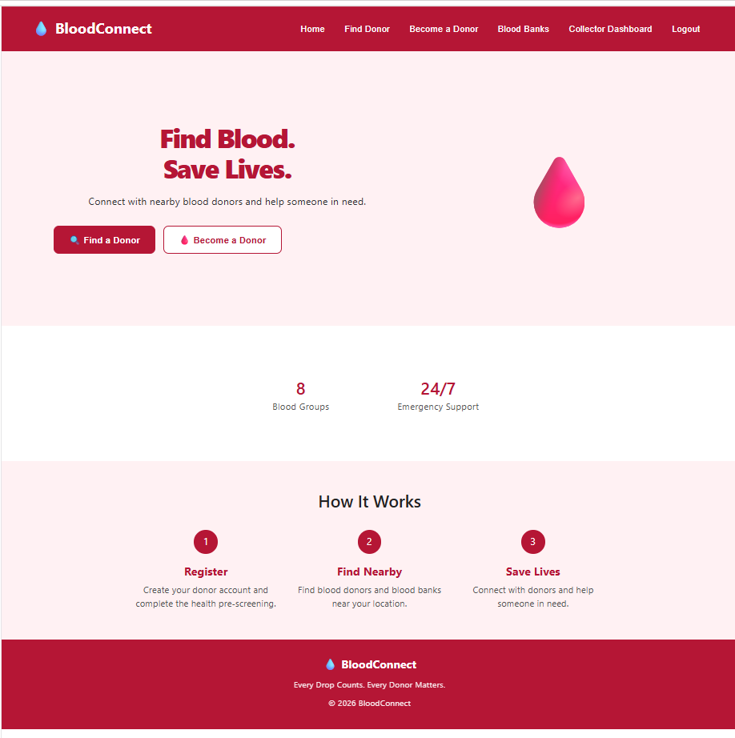

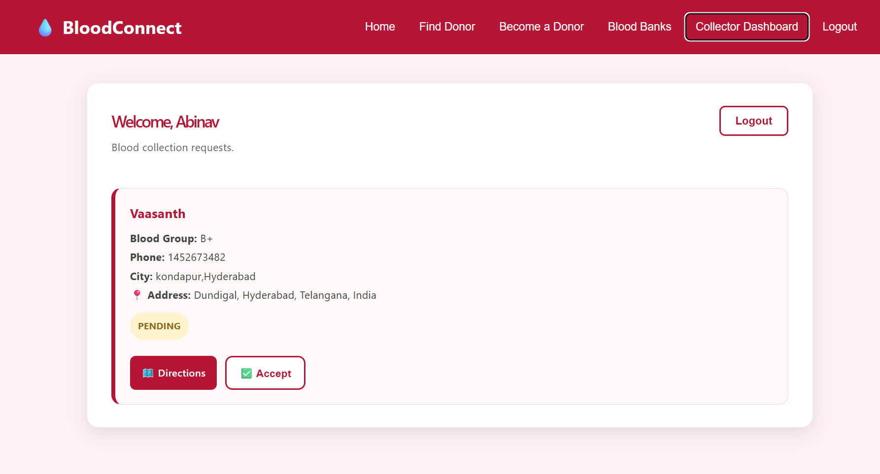

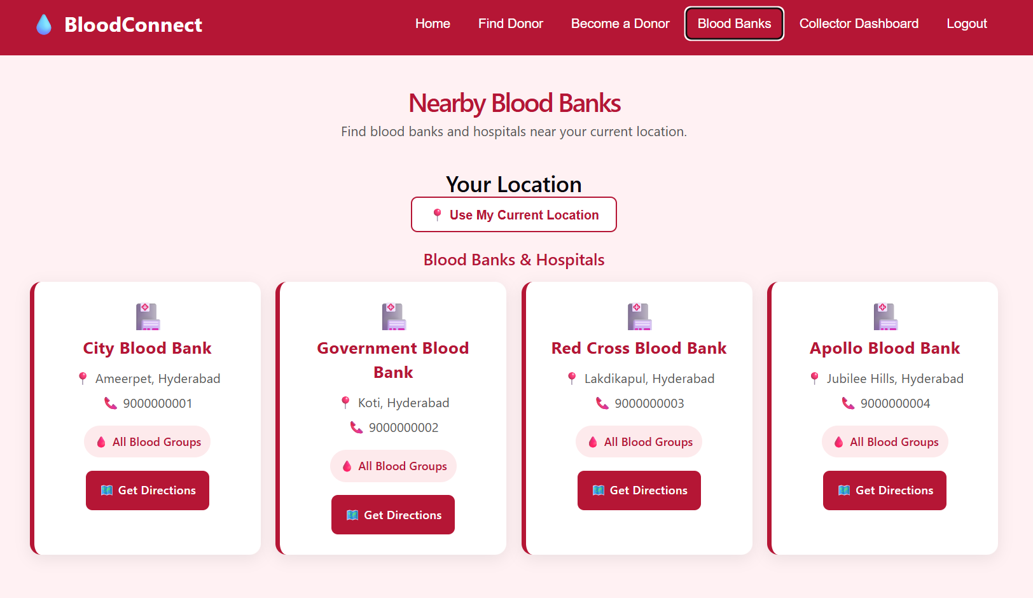

Sample code snippets

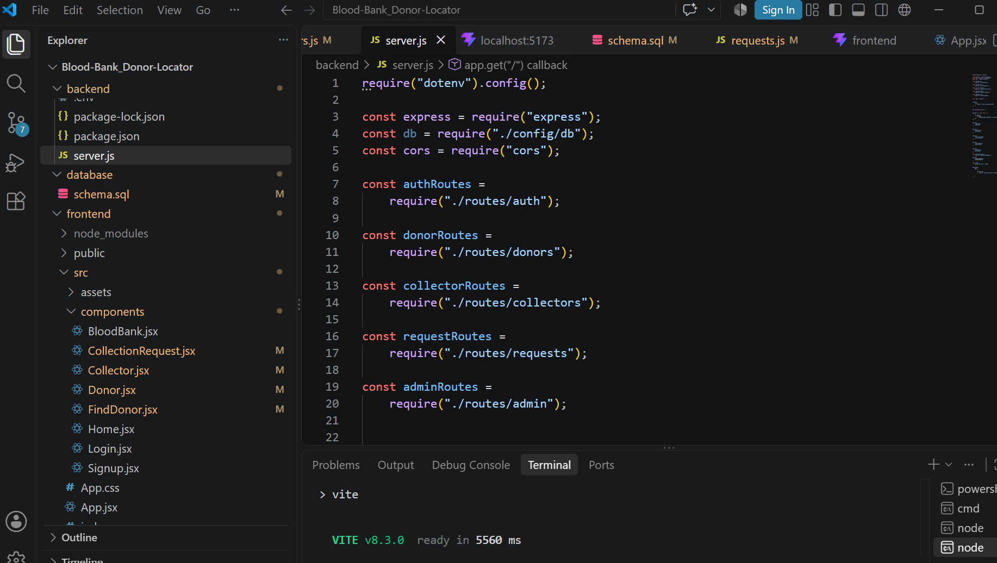

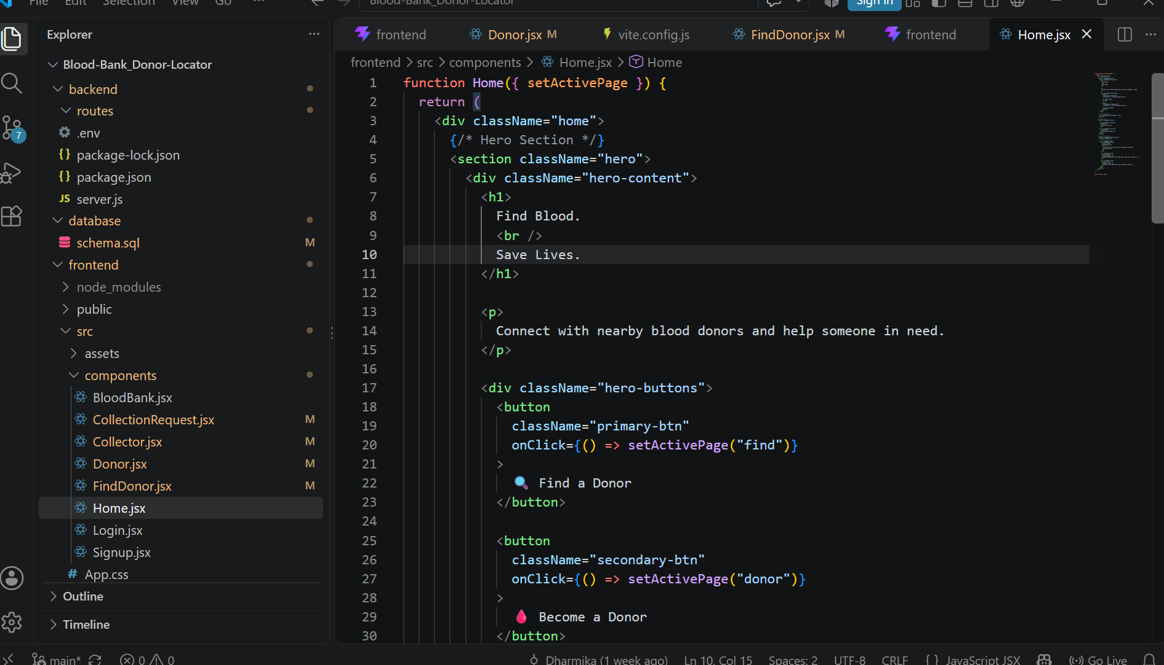

Installation / Setup Instructions

The Blood Bank Donor Locator App is developed using React.js for the frontend, Node.js and Express.js for the backend, and MySQL for database management. To install the application, first download or copy the complete project folder and open it in Visual Studio Code. Node.js and npm should be installed on the system before starting the setup.
Open the terminal in the frontend and backend folders and run npm install to install the required dependencies. Create the blood_bank database using MySQL Workbench and execute the provided SQL commands to create tables such as users, donors, blood_banks, and collection_requests. Configure the database connection and required environment variables in the backend.

After completing the configuration, start the Node.js and Express.js backend server and then start the React frontend using npm run dev. The application can be accessed through the local URL displayed by the React development server using a modern browser such as Google Chrome, Microsoft Edge, or Firefox.

User Manual / Guide

When the Blood Bank Donor Locator App is opened, the Home page provides navigation to the main features of the application. Donors can open the Donor Registration section and enter details such as name, age, blood group, phone number, city, location, and basic health-condition information. The system performs preliminary eligibility checking and displays the appropriate result.
Users can use the Find Donor section to search for donors based on blood group, name, city, or location. The application can also request browser location permission to capture latitude and longitude for location-based functionality. The Blood Bank section provides information about registered blood banks.
The Collection Request section allows collection requests to be created and managed. Collectors and administrators can use the Login section to access authorized management features. Collection requests can be tracked using statuses such as PENDING, ACCEPTED, COMPLETED, and CANCELLED. Users should provide valid information and allow location access when required for location-based features.

Geo Tag photos with guide

